**Adaptive Hysteresis Thresholding Segmentation Technique for Localizing the Breast Masses in the Curve Stitching Domain**

**Author: Bushra Mughal Nazeer Muhammad Muhammad Sharif**

**Method used in the paper:**

Presence of **pectoral muscle** in

breast mammogram highly affects the **detection process** of breast tumor.

A novel aspect of the proposed method is that the **curve stitching technique** is developed for removing of pectoral muscle. Following this, an **adaptive hysteresis thresholding is used for segmentation.** This hybrid technique is used for segmenting a breast region of digital mammogram with suppression of pectoral muscle.

**Results:**

**Sensitivity rate** is calculated here.

**96.6%** for the **MIAS dataset**

**96.4%** for the **DDSM dataset** as compared to existing methods.

**Proposed Method:**

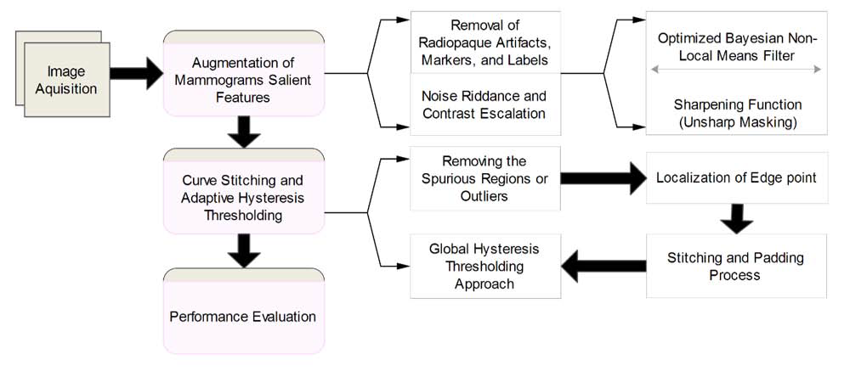

**On Data:**

Manual cropping to remove the artifacts.

**Enchancement Methods used**

Implement various **noise removal techniques top hat, bottom hat**, and

**optimized Bayesian non-local means filter** on our dataset for selection of an efficient noise removal technique. We found that **OBNLM** efficiently removes the noise while enhancing the edges and preserving the image structures [47, 48]. Each I be a preprocessed image which is normalized using I and then denoising operation f() is performed on I , inorder to get a noise free image

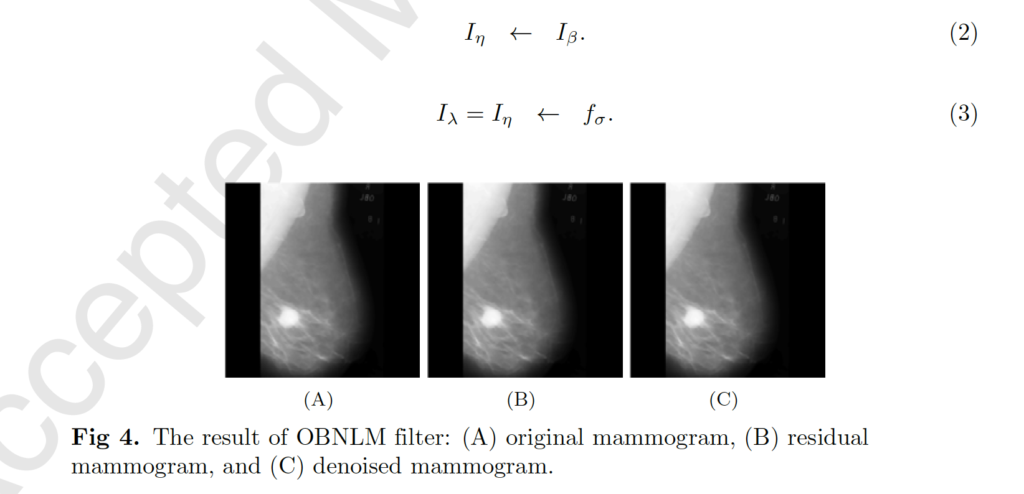

After **Implementation of optimized Bayesian non-local mean filter,** denoised mammogram I **needs to be sharpened for enhancing the features of mammogram**. A traditional sharpening filter is used in commercial software for un sharping, which was presented by Schreiber to improve the quality of pictures required for newspapers . This is banded on the principle of photographic masking to get the positive transparency of a low-contrast using the original negative data of the given mammogram. The desired mask is then incorporated with the original negative that produce the fuse data to crop the final pattern. This provide the sharpen outcome with an escalation trend. This is achieved by **detracting a blurred image from the original image. Unsharp masking indicate the high frequency details of mammogram, heightening a part of the band, which have the low signal to noise ratio (SNR). This often leads to noise amplification.**

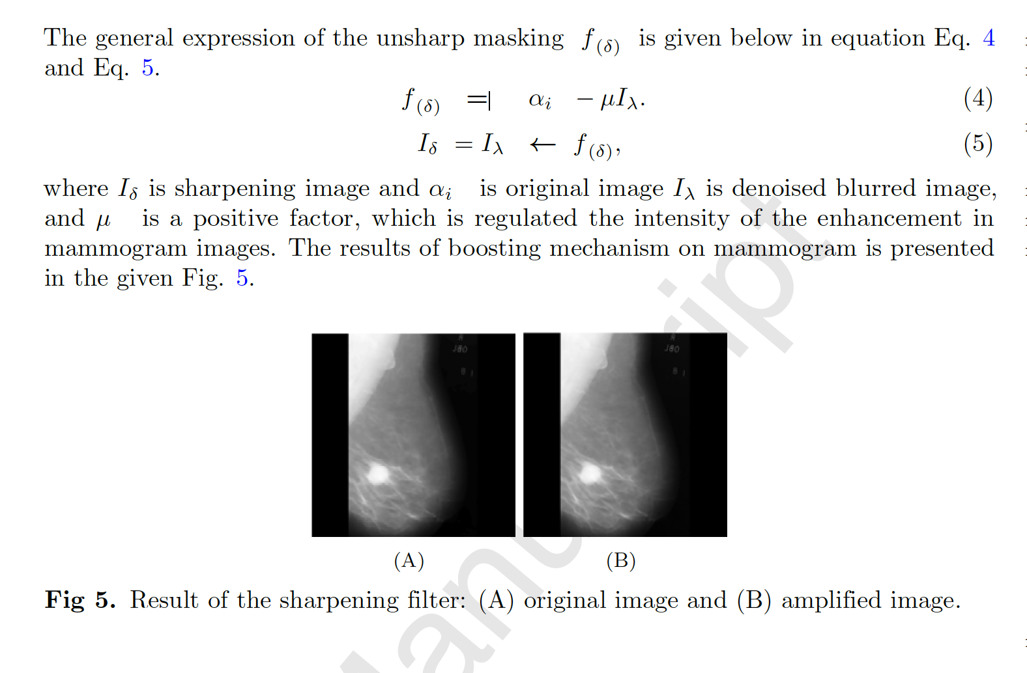

**Curve Stitching and Adaptive Hysteresis Thresholding**

* Removing the spurious regions or outliers
* Localization of Edge Point **Sobel Operator**

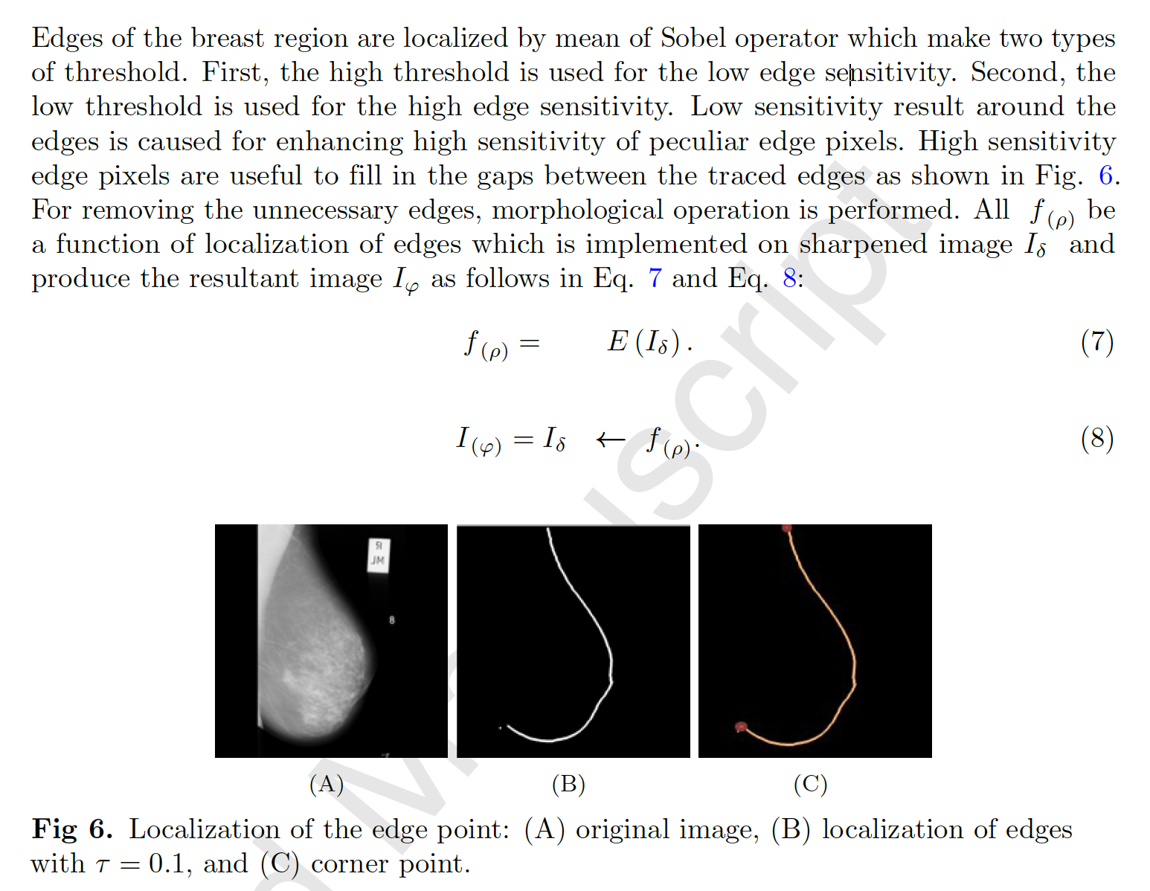

Stitching and Padding Process

Harris corner detector is used to locate the corner point of the broken breast boundary for stitching process

Global Hysteresis Thresholding Approach

Thresholding is used to generate a binary image from grey level values by setting all pixel's value with threshold between the range of 0 to 1.

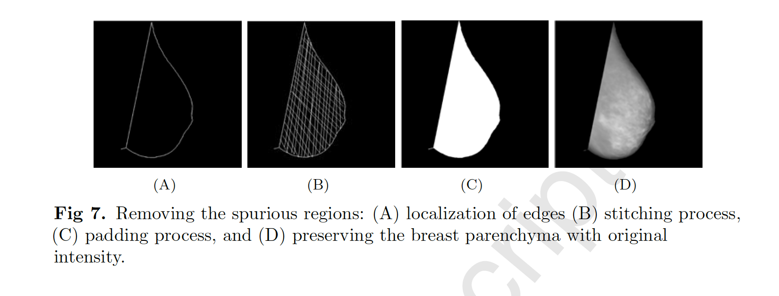

Adaptive hysteresis thresholding is used as 206

shown in I(l; k) =f; f(l; k) > threshold value

0; f(l; k) <=threshold value

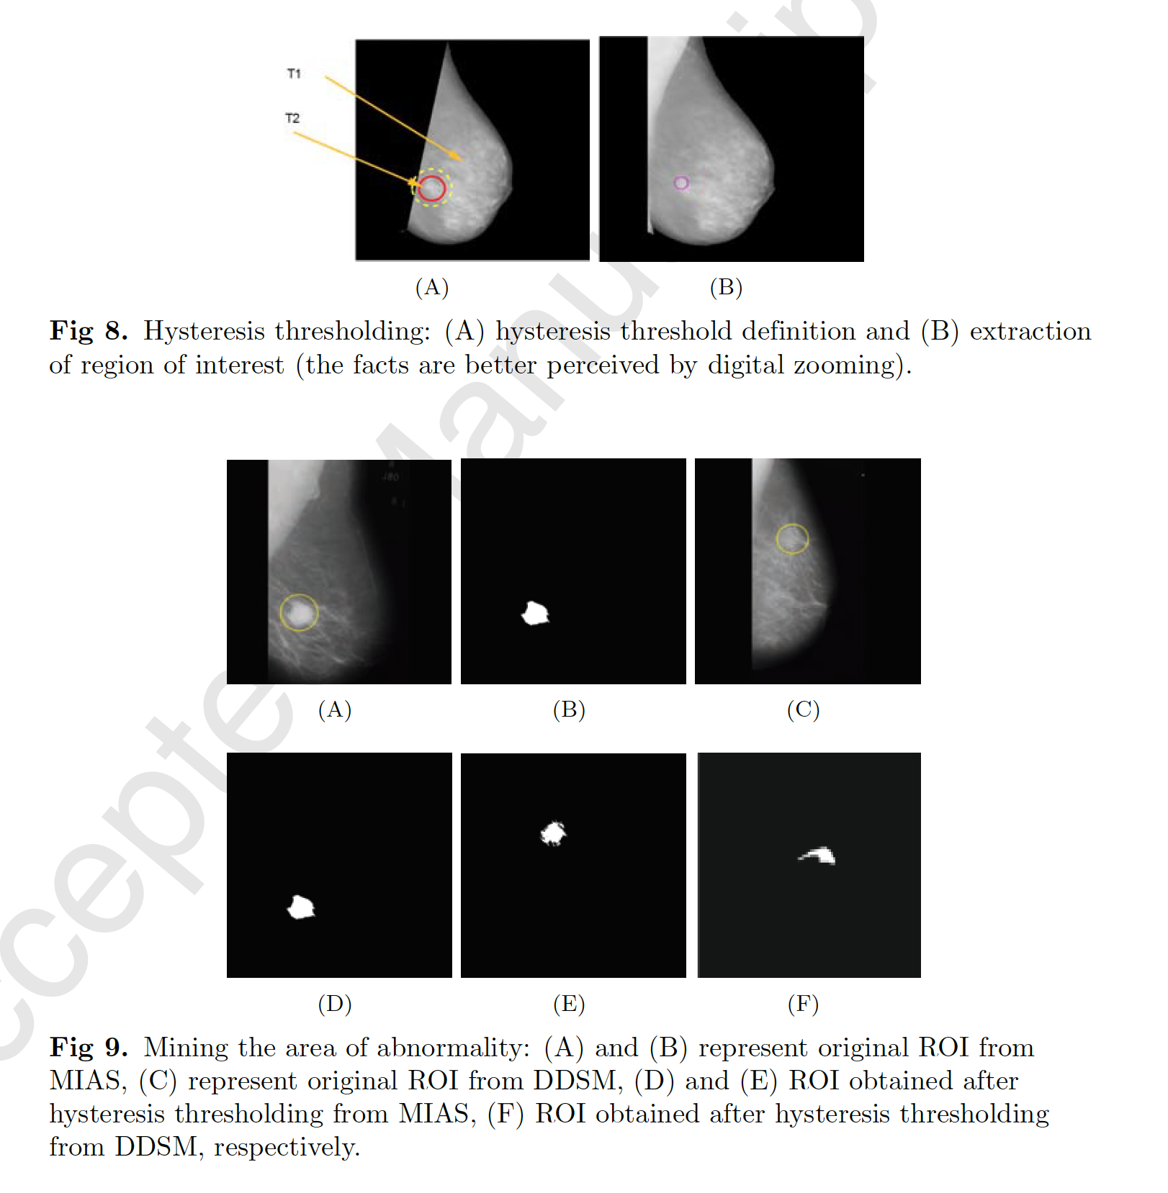

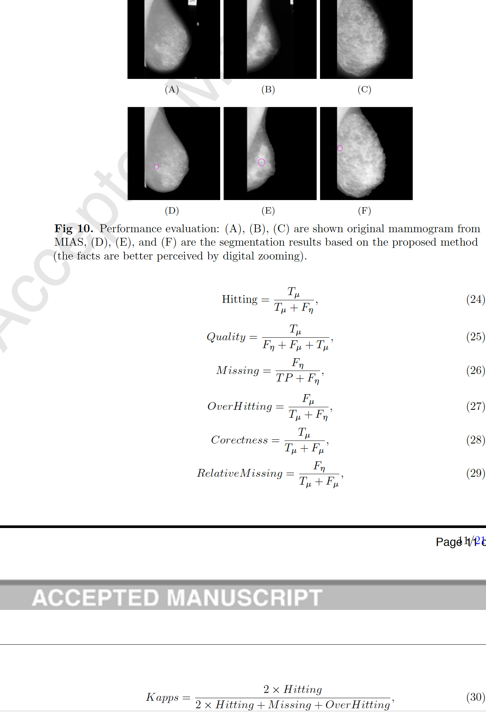

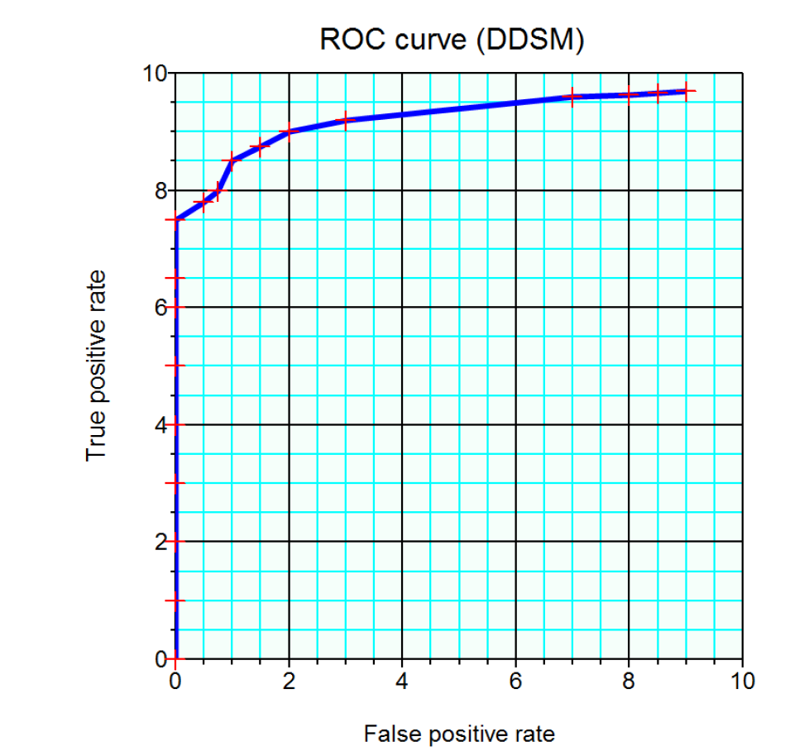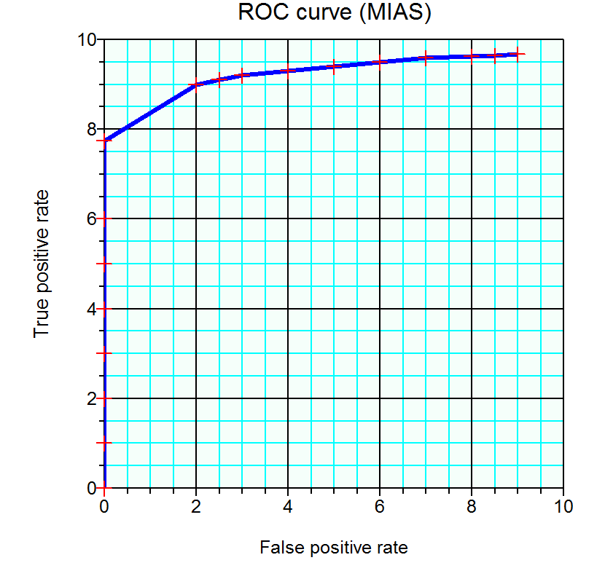

**AUNet: Attention-guided dense-upsampling networks for breast mass segmentation in whole mammograms**

**Authors :Hui Sun1, Cheng Li1, Boqiang Liu, Hairong Zheng, David Dagan Feng, Shanshan Wang\***

**Attention-guided dense-upsampling network (AUNet)** for accurate breast mass segmentation in whole mammograms directly.

In AUNet, we employ an **asymmetrical encoder-decoder structure and propose an effective upsampling block, attention-guided dense-upsampling block (AU block).**

Especially, the AU block is designed to have three merits.

* it compensates the information loss of bilinear upsampling by dense upsampling.
* it designs a more effective method to fuse high- and low-level features.
* Thirdly, it includes a channel-attention function to highlight rich-information channels.

We evaluated the proposed method on two publicly available datasets, **CBIS-DDSM and INbreast**. Compared to three state-of-the-art fully convolutional networks, AUNet achieved the best performances with an **average Dice similarity coefficient** of **81.8% for CBIS-DDSM and 79.1% for INbreast.**

**AUNet employs an asymmetrical structure – different encoder and decoder blocks – through the implementation of residual connections**

Novel upsampling module, attention-guided dense-upsampling block (AU block), to compensate the **information loss** caused by **bilinear upsampling**, effectively fuse the high- and low-level features, and at the same time, highlight the rich-information channels.

**Preprocessing**All the images along with the masks were first processed to remove the irrelevant background regions (rows and columns have negligible maximum intensities).

Then **resized to 256 x 256**, followed by an **intensity normalization.** Before inputting into the networks, the gray images were changed to RGB images by copying the pixel values to the other two channels.

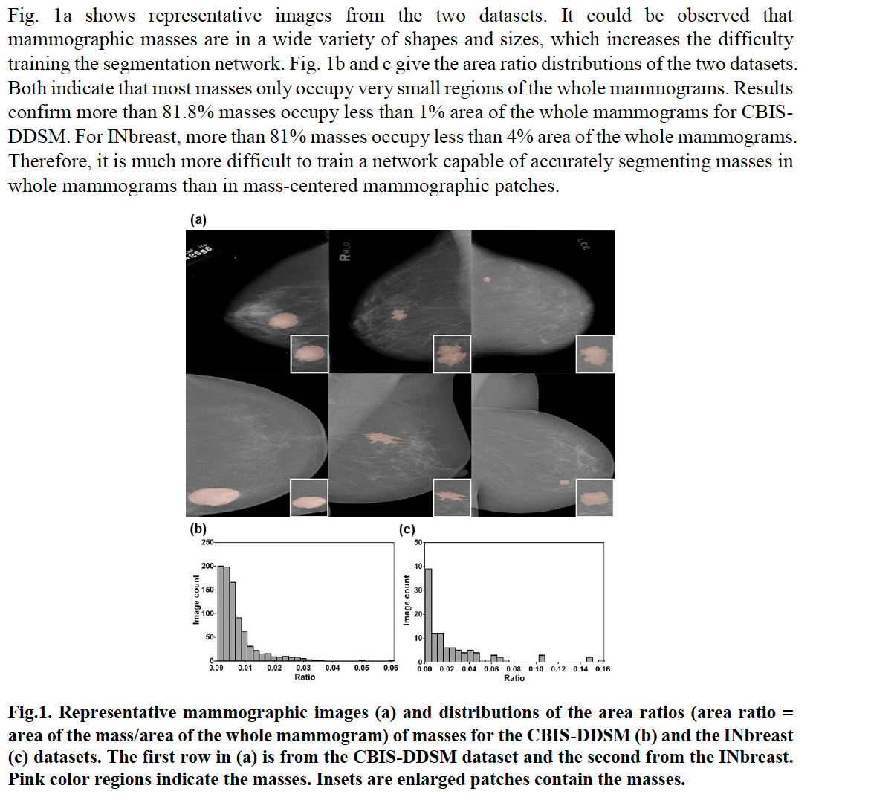

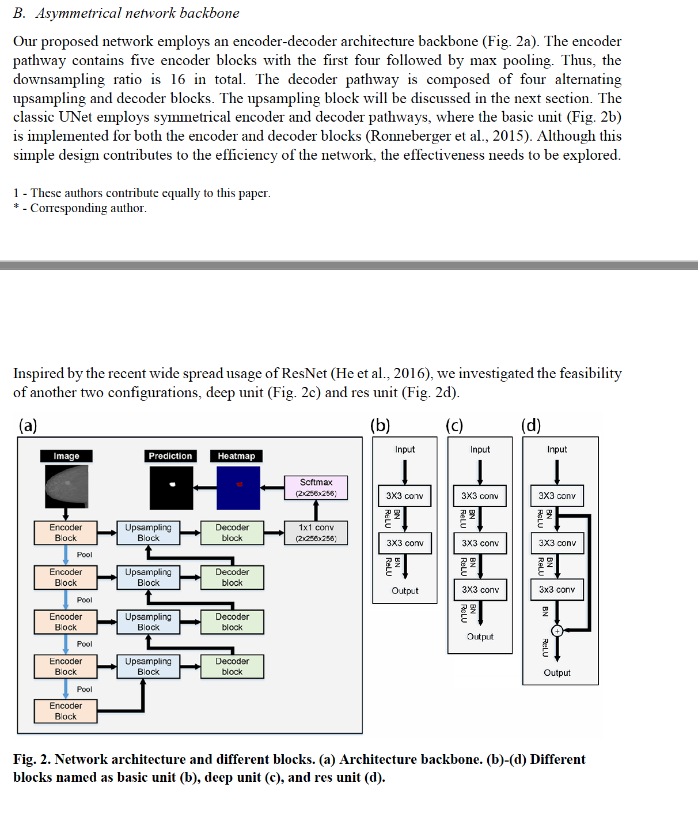

For the three different units, we have the respective outputs as follows:

𝑦𝑏𝑎𝑠𝑖𝑐(𝑥)=𝛿((𝑊𝑏2∗(𝛿(𝑊𝑏1∗𝑥+𝑏𝑏1))+𝑏𝑏2)

𝑦𝑑𝑒𝑒𝑝(𝑥)=𝛿(𝑊𝑑3∗(𝛿((𝑊𝑑2∗(𝛿(𝑊𝑑1∗𝑥+𝑏𝑑1))+𝑏𝑑2))+𝑏𝑑3)

𝑦𝑟𝑒𝑠(𝑥)=𝛿((𝑊𝑟3∗(𝛿((𝑊𝑟2∗(𝛿(𝑊𝑟1∗𝑥+𝑏𝑟1))+𝑏𝑟2))+𝑏𝑟3)+(𝑊𝑟1∗𝑥+𝑏𝑟1))

where y is the respective output of the different units and x is the corresponding input. refers to the ReLU function. W and b refer to the weights and bias of the different convolution

layers. * is the convolution operation.

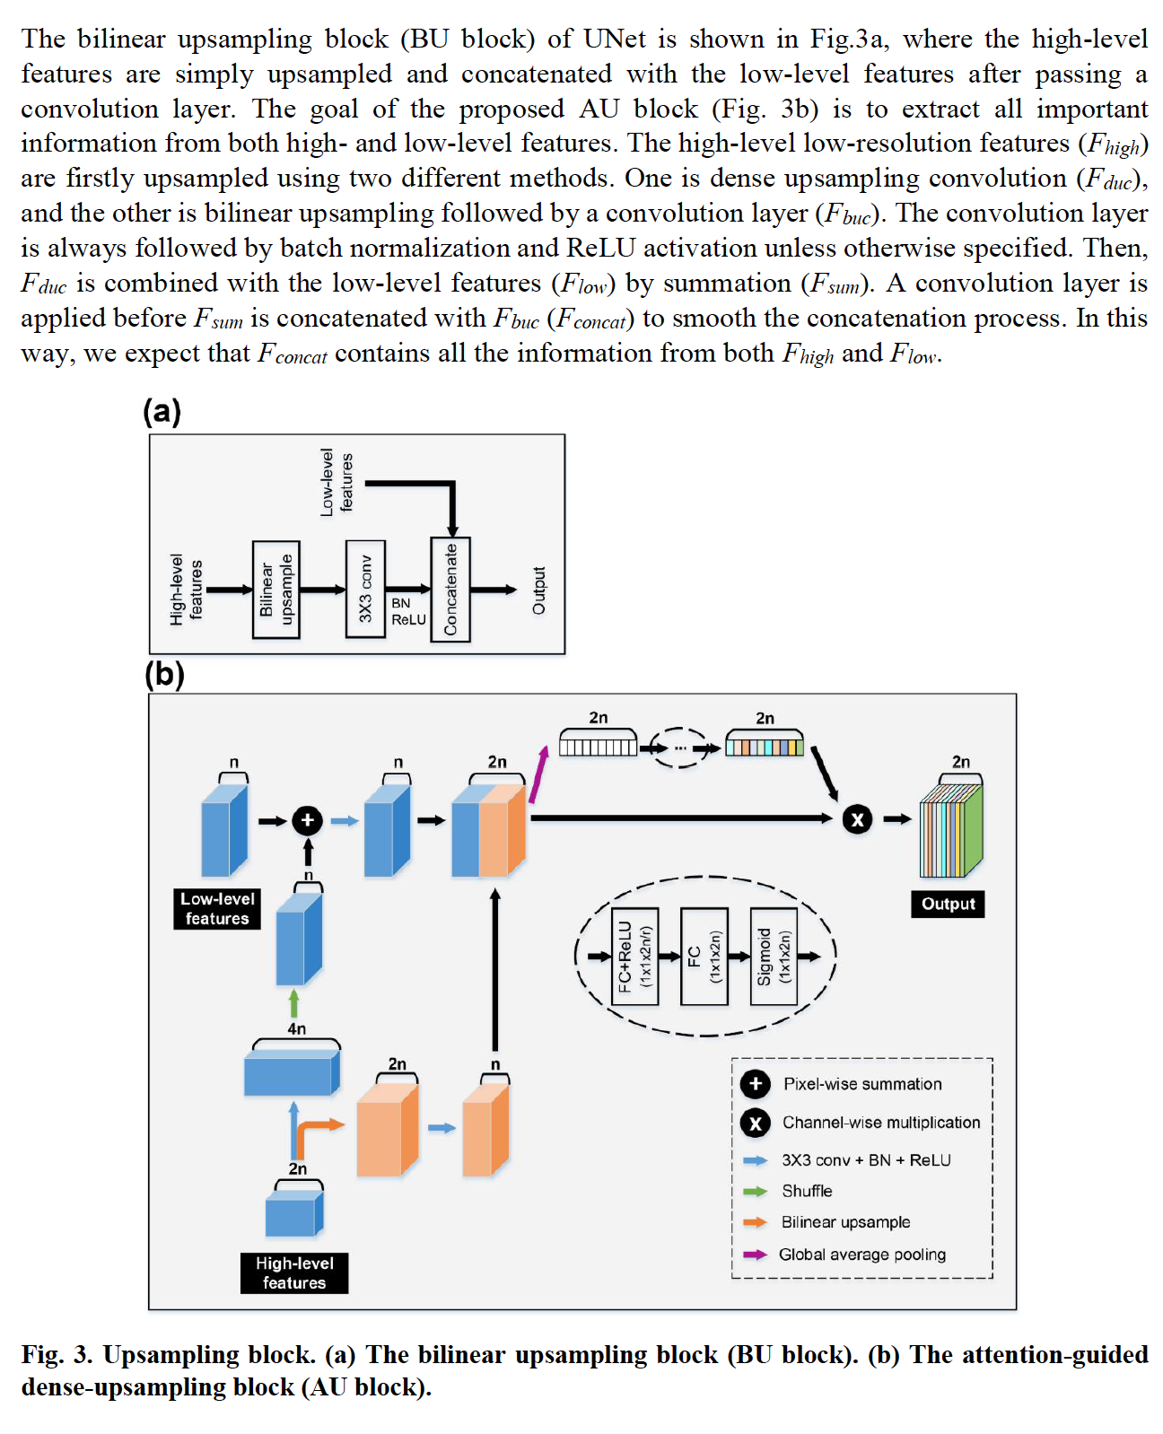

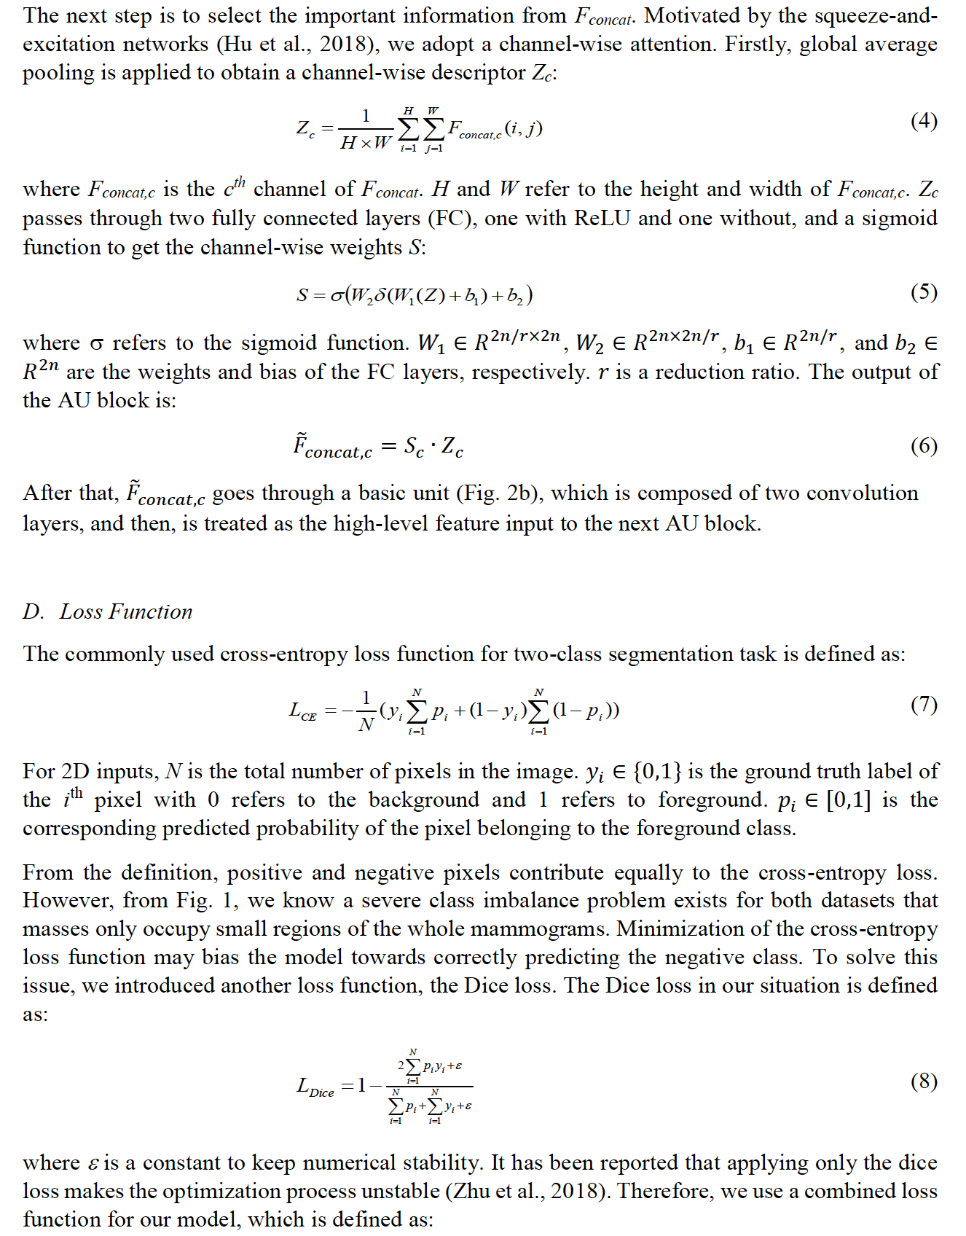

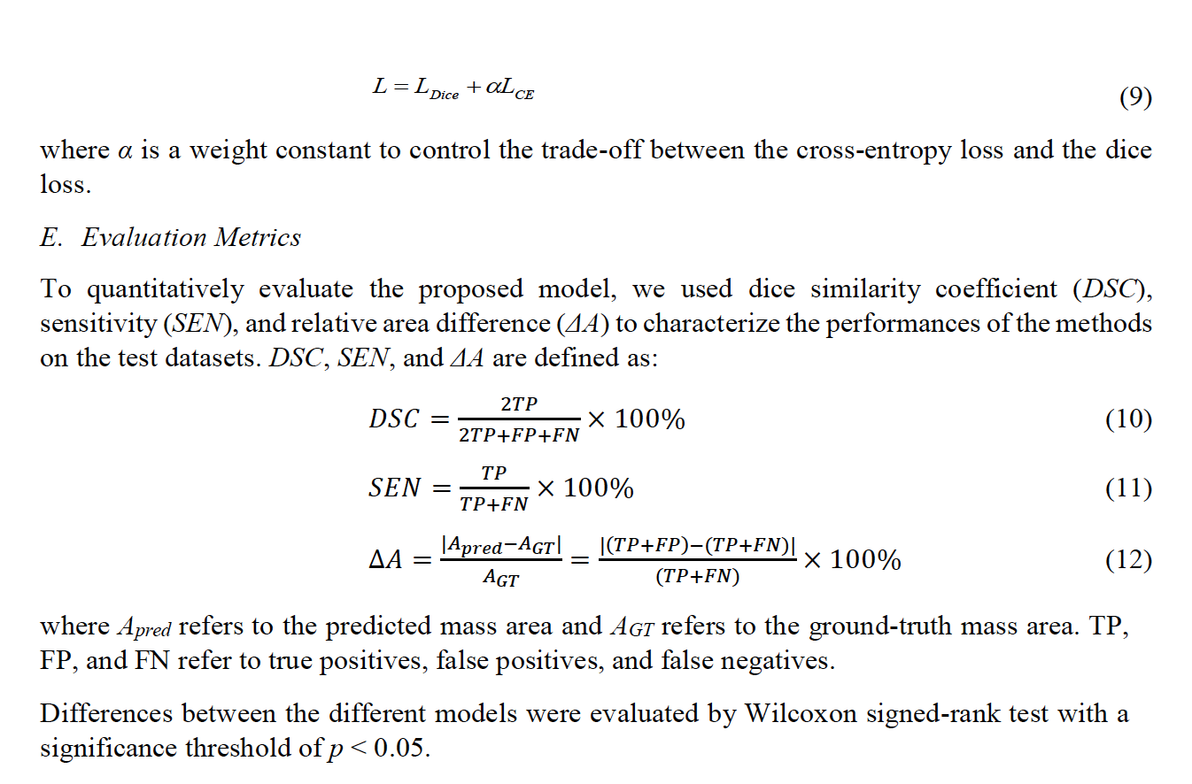

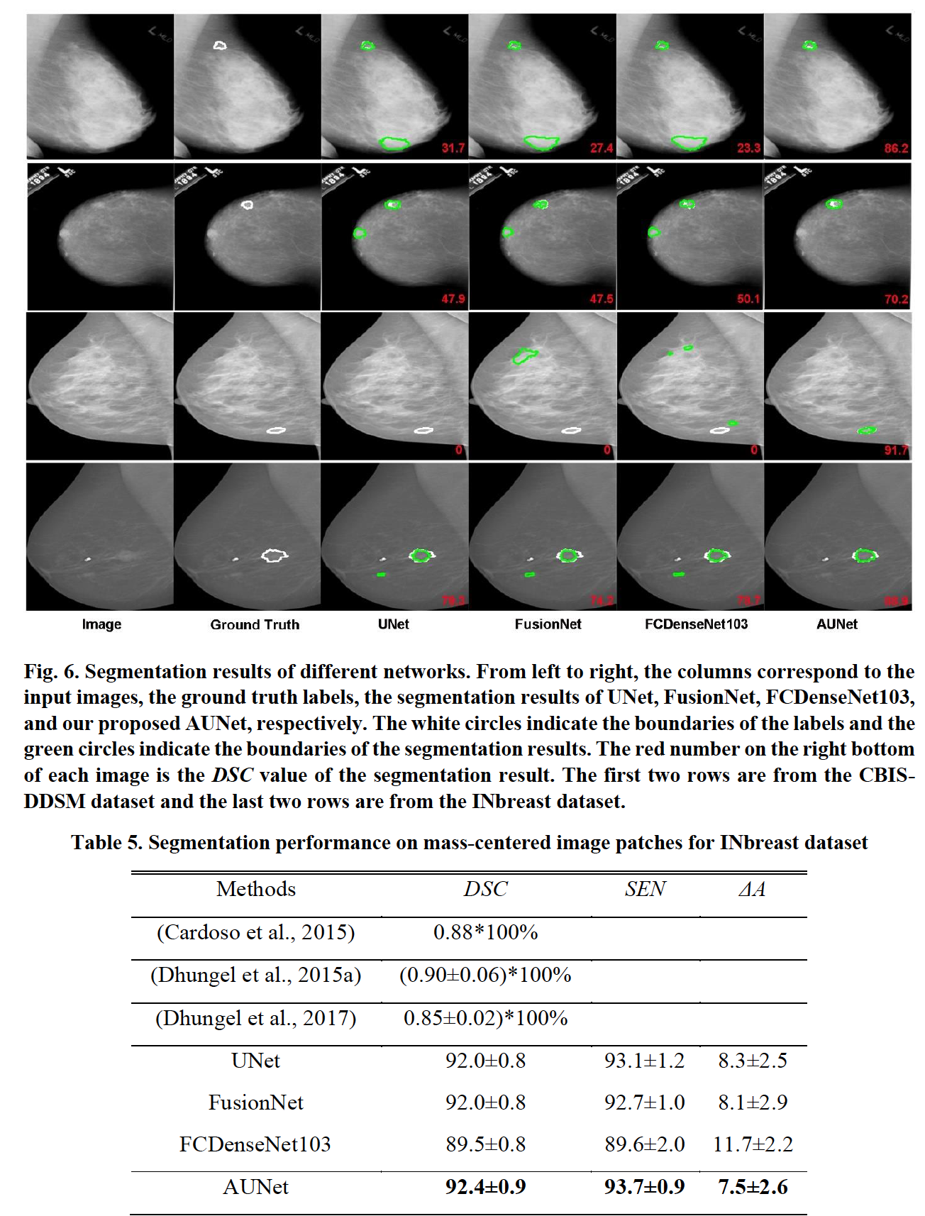

**Improved Breast Mass Segmentation in Mammograms with Conditional Residual U-Net**

**Heyi Li1, Dongdong Chen, William H. Nailon, Mike E. Davies,**

**and David Laurenson**

Conditional Residual U-Net (CRU-Net), to improve the U-Net segmentation performance. Benefiting from the advantage of probabilistic graphical modelling in the pixel-level labelling, and the

structure insights of a deep residual network in the feature extraction, the CRU-Net provides excellent mass segmentation performance. Evaluations based on INbreast and DDSM-BCRP datasets demonstrate that the CRU-Net achieves the best mass segmentation performance compared to the state-of-art methodologies. **Moreover, neither tedious pre-processing nor post-processing techniques are not required in our algorithm.**

the **CRU-Net** is proposed to precisely segment breast

masses with small-sample-sized mammographic datasets. Our main contributions include:

**(1) the first neural network based segmentation algorithm that**

**considers both pixel-level labelling consistency and efficient training via integrating the U-Net with CRF and deep residual learning**

**(2) the first deep learning mass segmentation algorithm, which does not require any pre-processing or post-processing techniques**

**(3) the CRU-Net achieves the best mass segmentation performance on the two most commonly used mammographic datasets when compared to other related methodologies.**

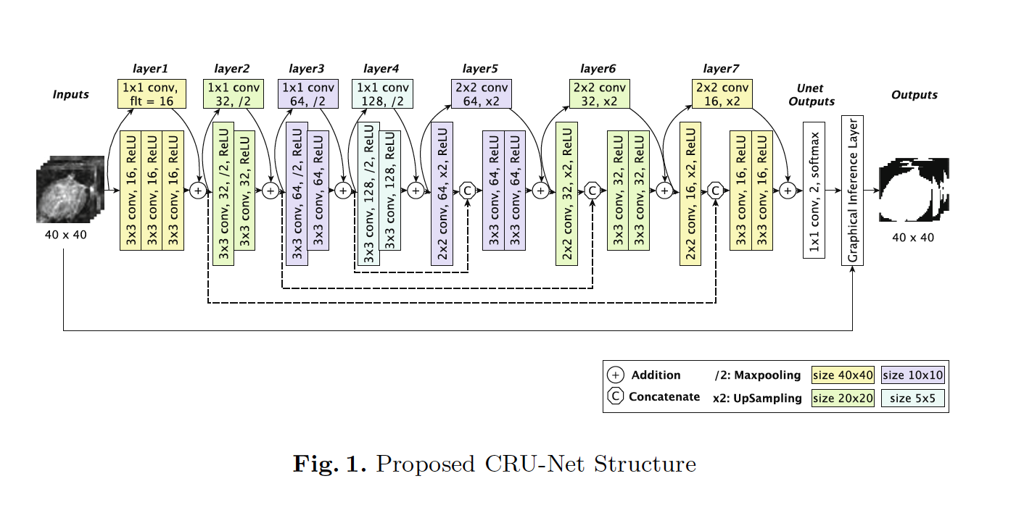

**U-Net with Residual Learning**

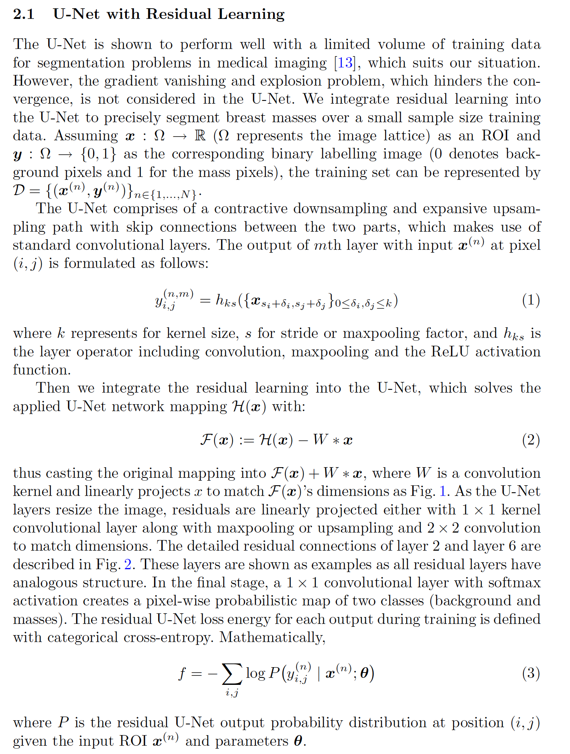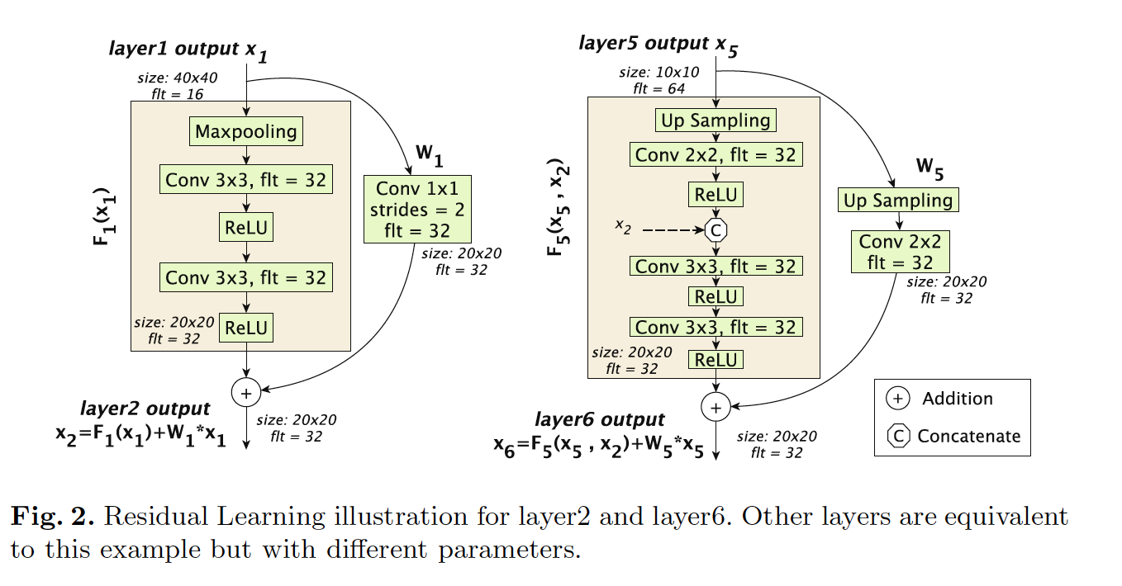

The proposed method is evaluated on two publicly available datasets **INbreast** and **DDSM-BCRP**

**In INbreast, the best Dice Index (DI) 93.66% is obtained with CRU-Net, No R (λ = 0.67) and a similar DI 93.32% is achieved by**

**its residual learning; while in DDSM-BCRP, all state-of-art algorithm performs similarly and the best DI 91.43% is obtained by CRU-Net (λ = 0). The CRU-Net performs worse on DDSM-BCRP than INbreast, which is because of its worse data quality. To better understand the dice coefficients distribution in test sets,**

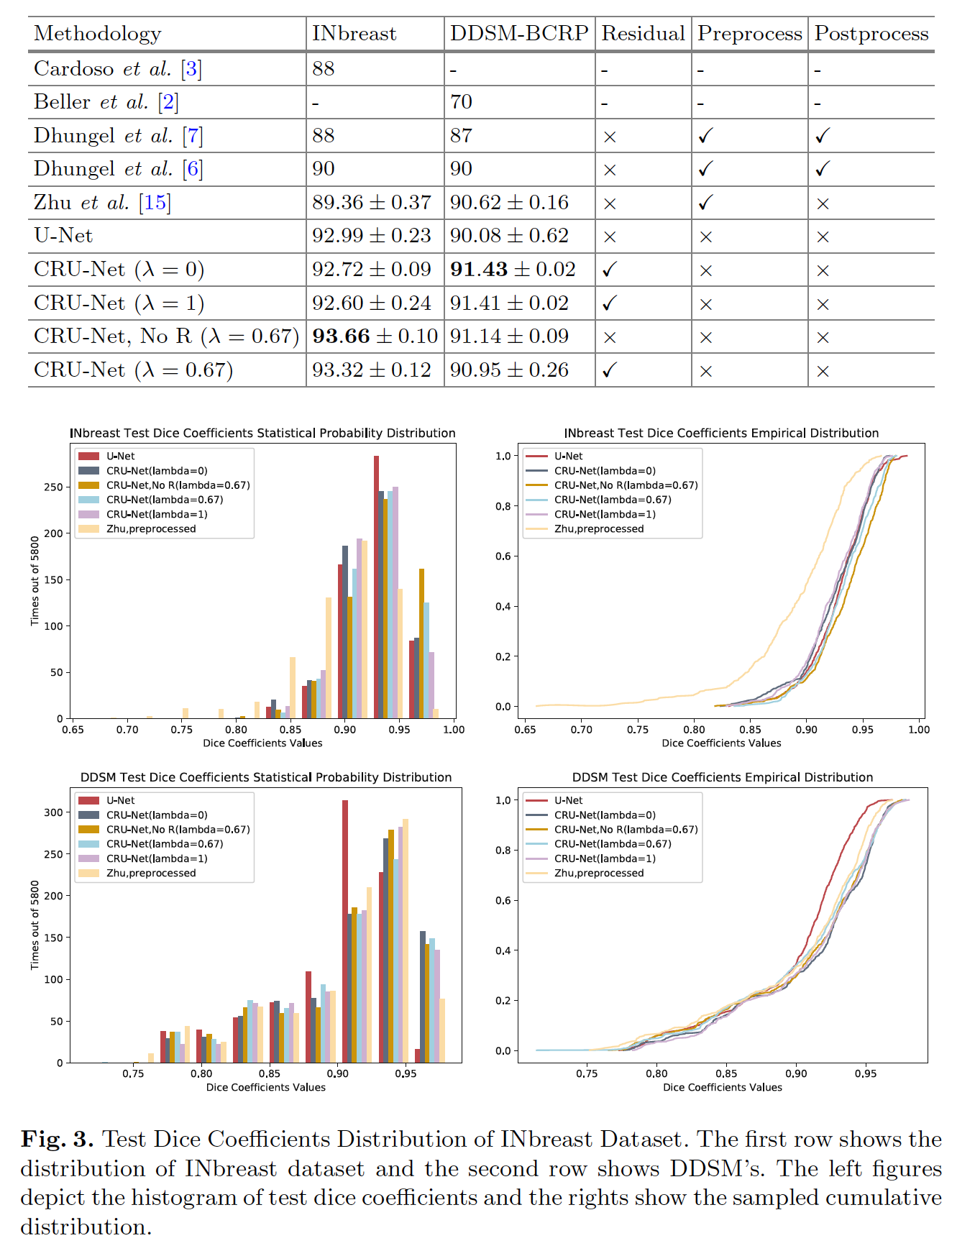

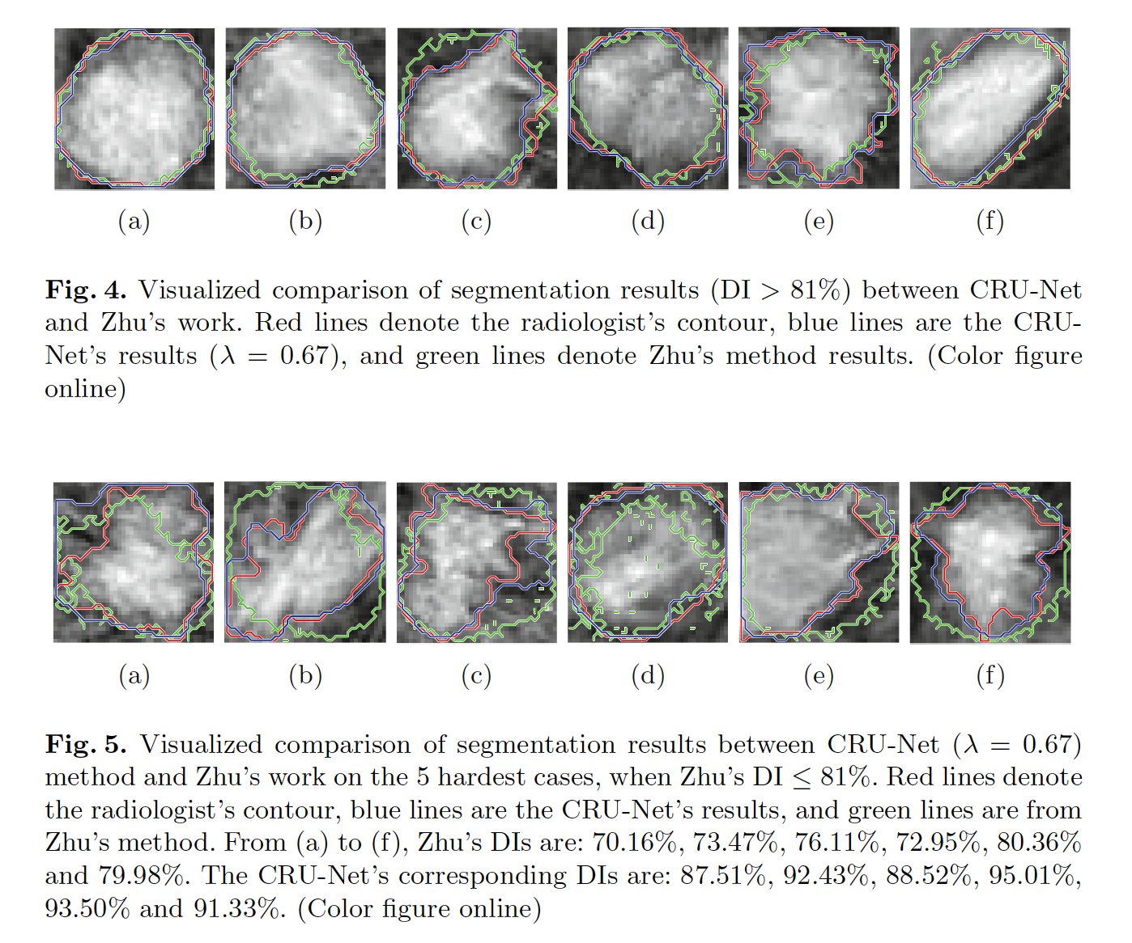

**Conclusions**

CRU-Net to improve the standard U-Net segmentation

performance via incorporating the advantages of probabilistic graphic models and deep residual learning. The CRU-Net algorithm does not require any tedious preprocessing or postprocessing techniques. It outperforms publishedstate-of-art methods on INbreast and DDSM-BCRP with best DIs as 93.66% and 91.14% respectively. In addition, it achieves higher segmentation accuracy when the applied database is of higher quality. The CRU-Net provides similar contour shapes (even for hard cases) to the radiologist with less noisy boundary, which plays a vital role in subsequent cancerous diagnosis.

**Examination of Digital Mammogram using Otsu’s Function and Watershed Segmentation**

S.P. Sachin raj, N. Sri Madhava Raja, M.R. Madhumitha, V. Rajinikanth

Department of Electronics and Instrumentation Engineering,

St.Joseph’s College of Engineering,Chennai

A novel hybrid approach based on the combination Otsu’s multi-thresholding and Water Shed Segmentation (WSS) to mine the suspicious sections from the DM. Initially, the multi-level thresholding using the Bat Algorithm

(BA) driven Otsu with a bi-, tri- and four-level thresholding is implemented to pre-process the DM. Afterward, a marker controlled WSS is implemented to mine the infected division of DM. The mined section is then evaluated using the Haralick texture feature in order to know the severity of the disease by examining its texture feature. In this paper, DM dataset with dense, medium, low and normal breast regions are analyzed independently with the proposed approach. The experimental result of this paper confirms that, proposed method is very proficient in extracting the breast malignancy from the considered DM database.

Hence, in this paper a recent heuristic procedure called Bat Algorithm (BA) is considered to examine the DM image database. The implemented technique

is the combination of a multi-level thresholding based on the BA and Otsu’s thresholding and segmentation based on the Watershed. The advantage of the thresholding and segmentation procedures are confirmed with the image quality measures and the GLCM values respectively.

**Methodology**

Initially, the 2D DM is extracted from the mini-MIAS and it is then thresholded

with CBA+Otsu. The outcome of thresholding is then processed with the watershed algorithm and the region of interest (ROI) is extracted. Finally, the GLCM features for the ROI are extracted. Based on the GLCM values, it can be classified into benign and malignant.

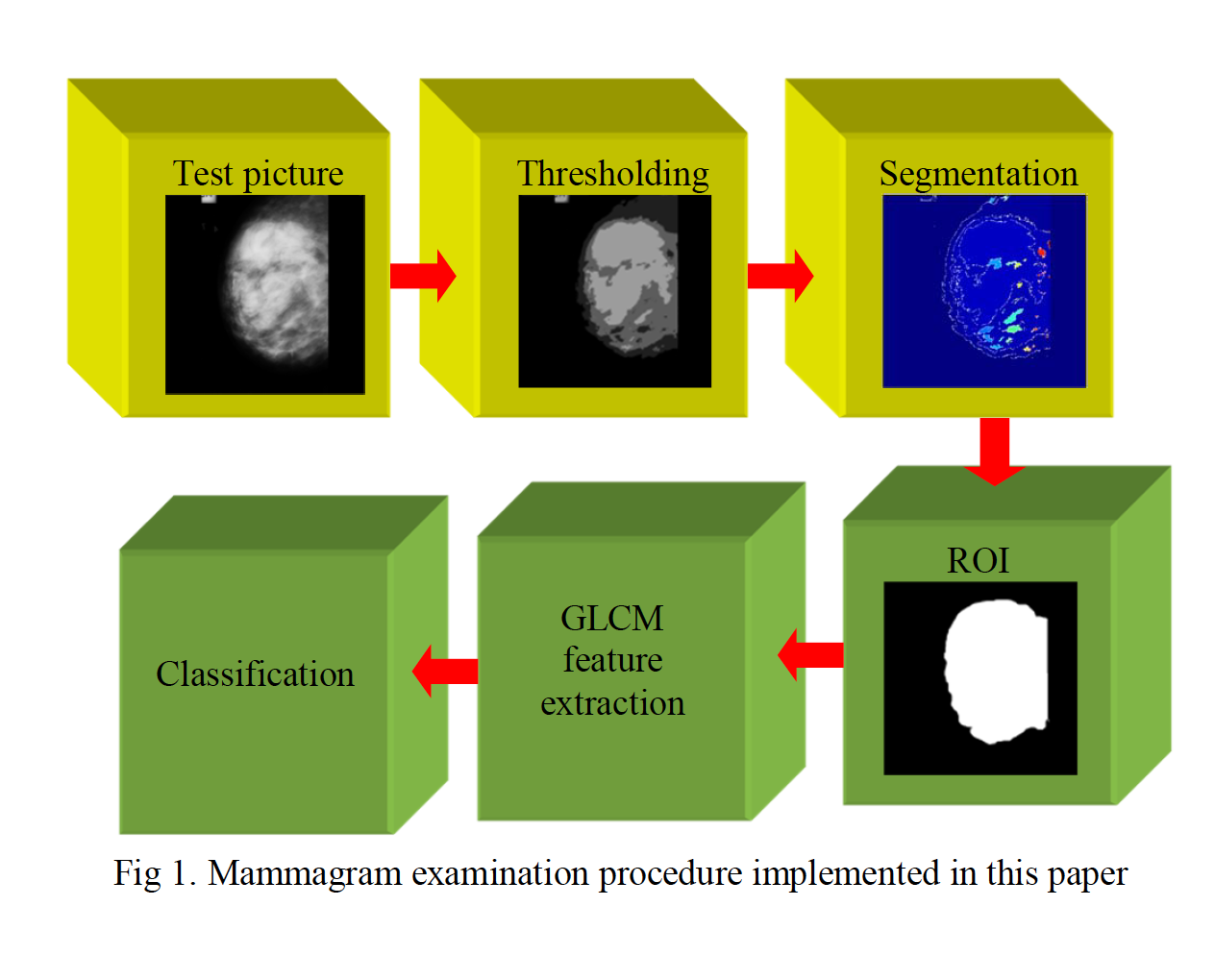

Dataset:

Digital mammogram (DM) is normally recorded using Xray on a chosen breast section. 2D DM pictures considered in this paper are obtained from the benchmark mini-MIAS database more than 50 in both malignant and benign subjects are considered . This dataset has a gray scaled 2D DM with major category as benign and malignant and sub classification as fatty, fatty-glandular and dense-glandular. This work considers the mini-MIAS and segregates the DM images into four classes, like normal, low, medium and dense based on the size of the irregularity.

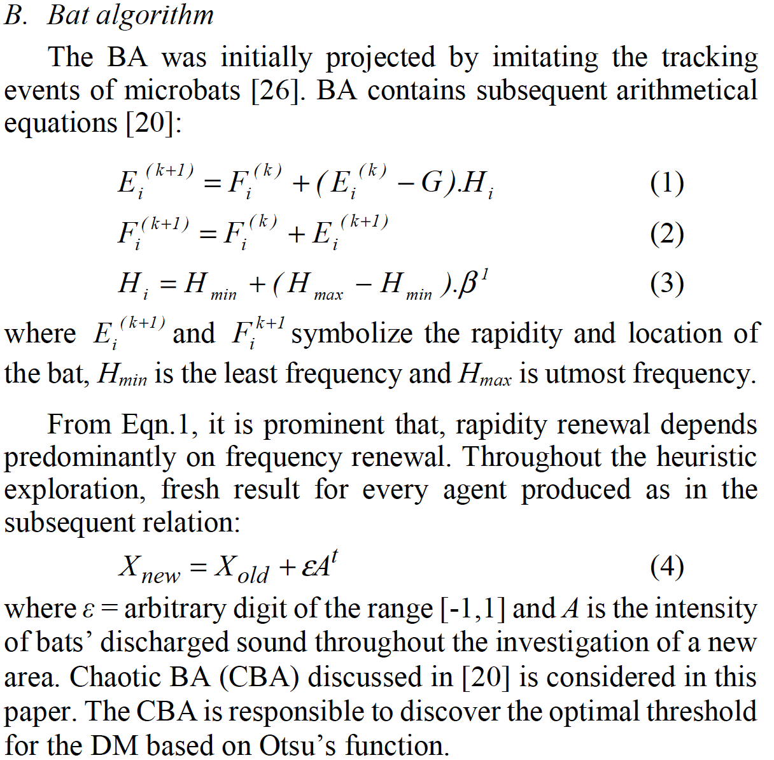

Otsu Thresholding

Let us consider that there are thresholds , such as t1,

t2, and tm, which partition the input picture into separate

sections, such as C0 (gray levels of range 0 to t1-1), C1 (gray

levels of range t1 to t2-1) and, Cm (gray levels of range tm-1 to L-

1). Where L = 256.

Objective value for this multi- thresholding can be expressed as;

Jmax = σ0 + σ1+… + σm (5)

More aspect regarding the Otsu is existing in the literature.

Eqn.4 is known as the Otsu’s between class variance function

which supports the exploration process of Chaotic BA search.

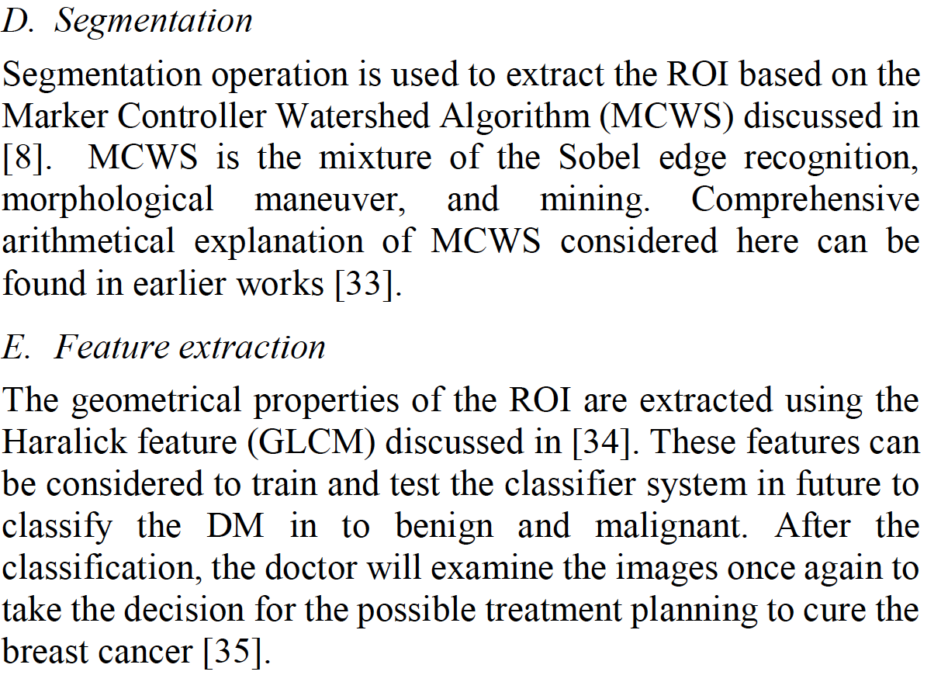

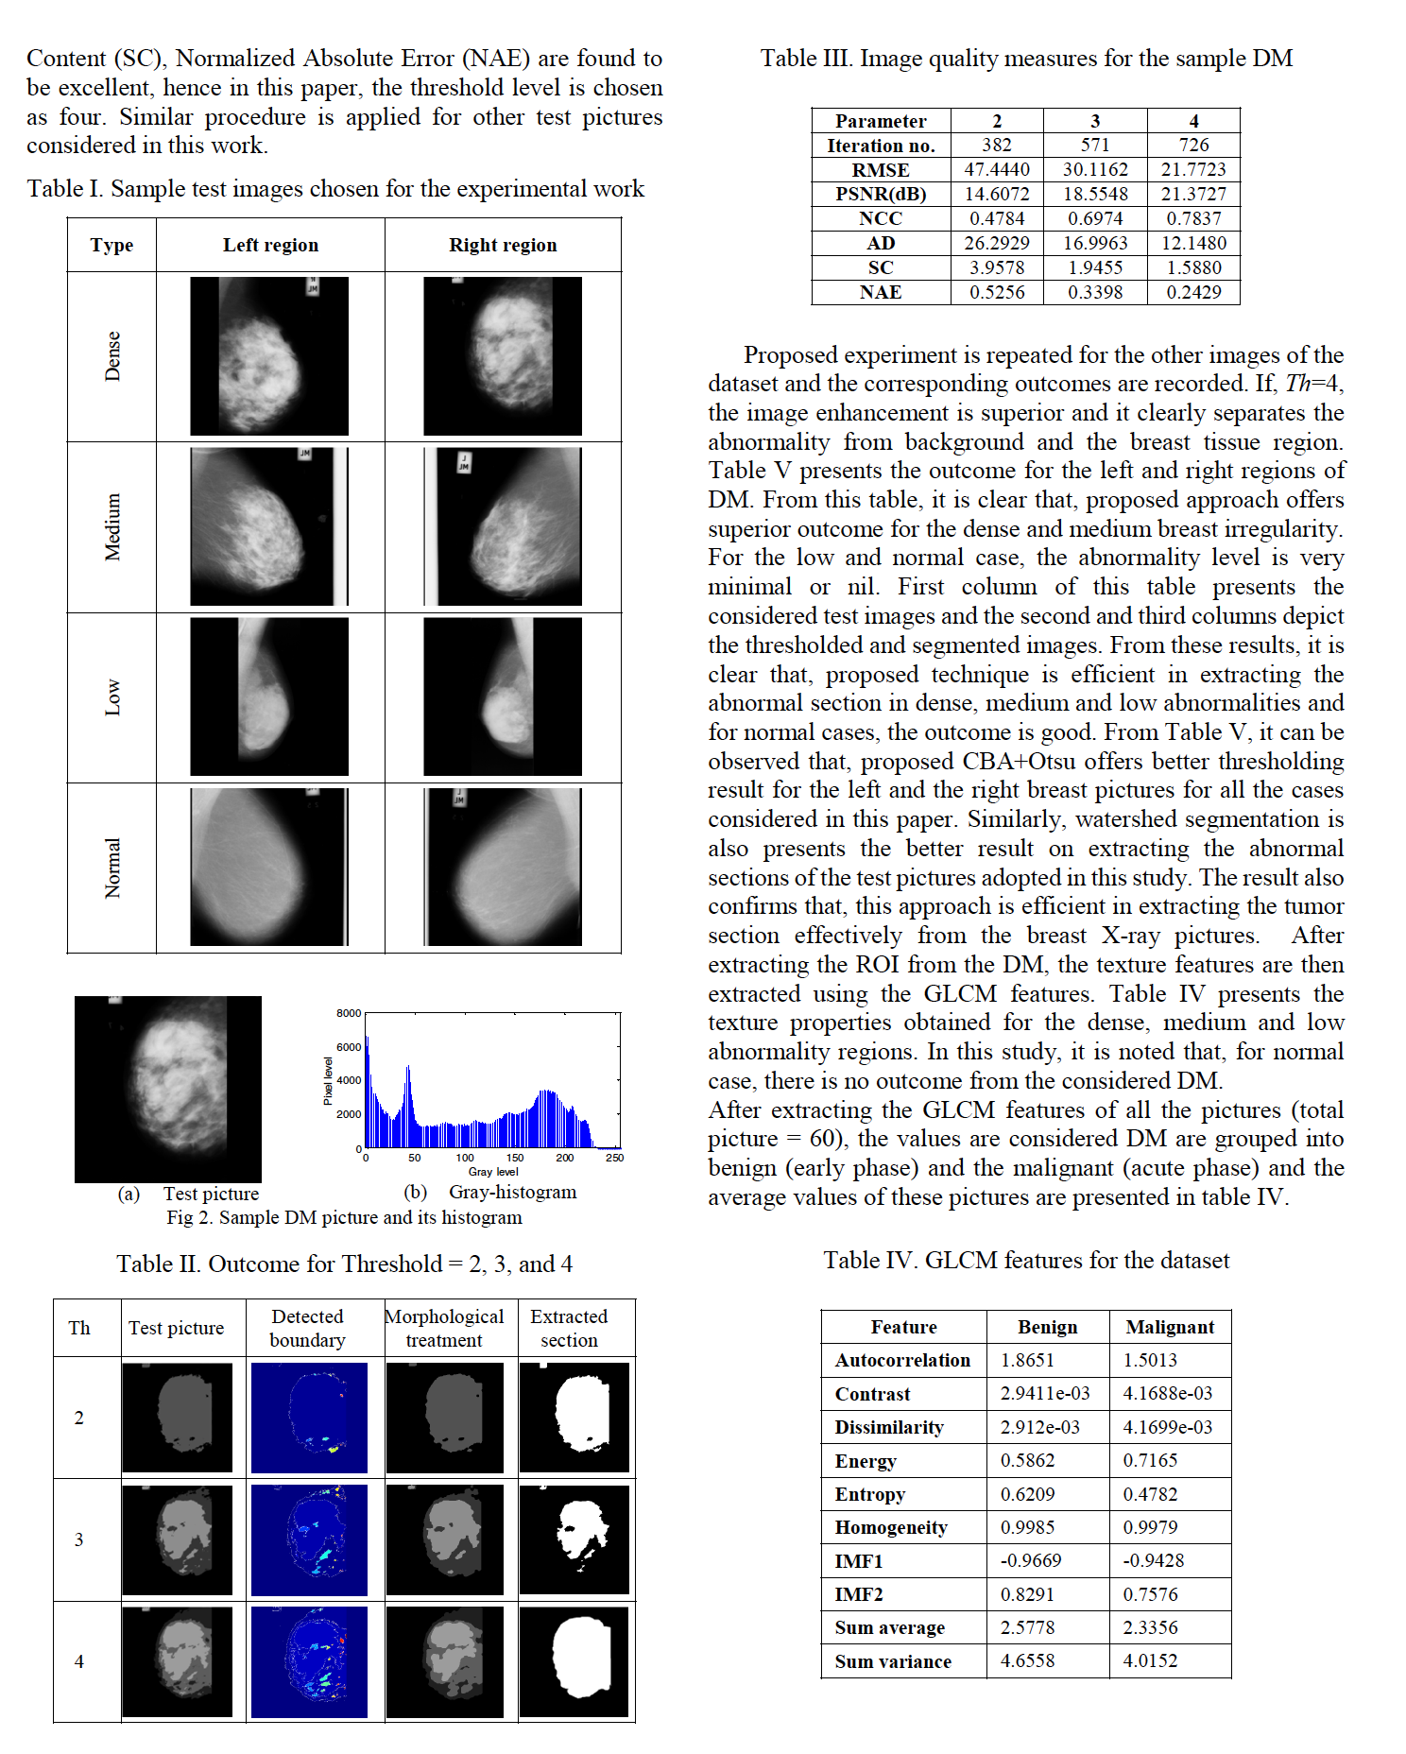

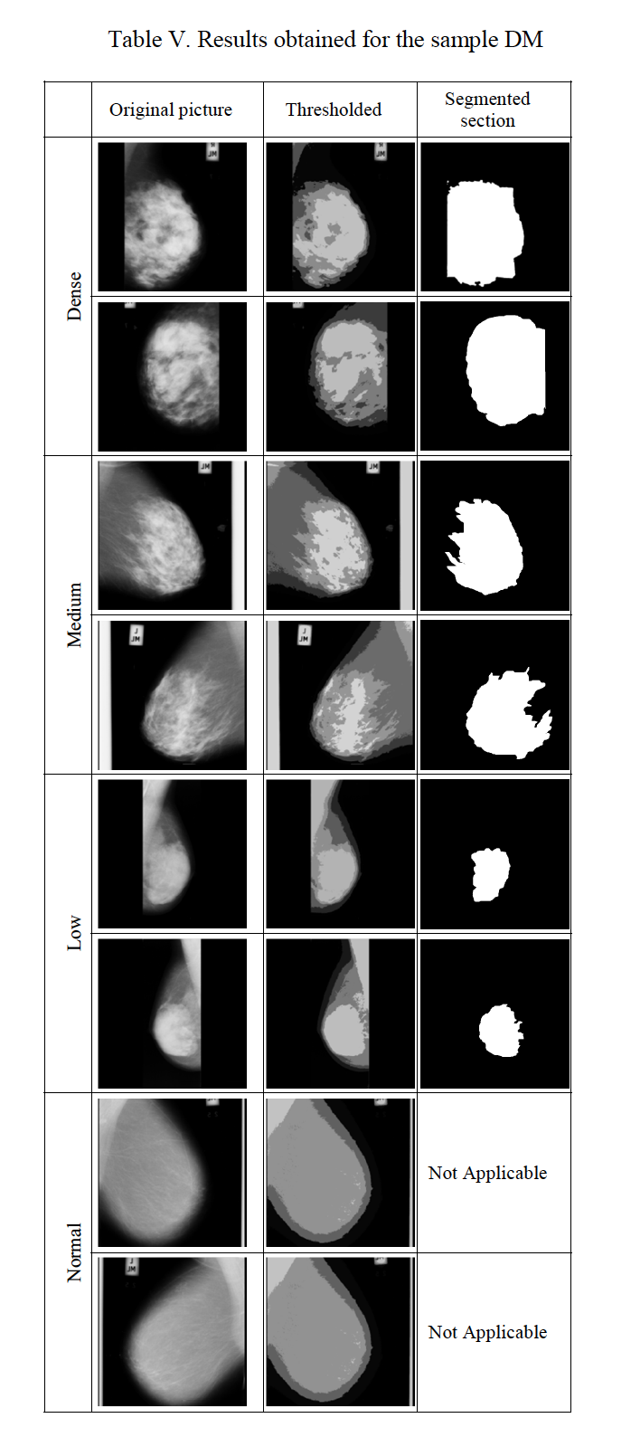

**Conclusion**

In this paper, a technique is proposed based on the combination of **multi-thresholding and Watershed Segmentation (WS) to examine the Digital Mammogram (DM) dataset of mini-MIAS. Initially, CBA+Otsu based thresholding is implemented to enhance the abnormal section from the DM. later; the improved section is extracted using the WS.** Later, the texture properties of the extracted section is computed based on the **GLCM**. In this work pictures, like dense, medium, low and normal images are examined using the proposed approach and is classified into benign and malignant based on its GLCM values. The results of this study confirm that, proposed approach is efficient in mining the abnormal section from the DM. In future, the proposed approach is to be compared against the related approaches already proposed by the researchers and a classifier system is to be implemented to classify the DM dataset into various disease classes. Further, validations with their corresponding ground truths can also be compared to estimate the efficacy of the segmentation.

**Fractional-Order Darwinian Swarm Intelligence Inspired Multilevel Thresholding for Mammogram Segmentation**

Santhos Kumar A., A. Kumar, V. Bajaj and G. K. Singh

Abstract—**Multilevel thresholding** is more accurate than the classical thresholding method for segmenting a digital mammogram, since **it uses more number of intensities** to represent the objects. It is intuitively appreciable for further detection of breast cancer using such kind of clinical database.**The main goal of any multilevel thresholding based segmentation is to optimize its objective function to obtain different threshold levels; but multilevel thresholding is computationally expensive, and sometimes these optimized values are not accurate.** Therefore, in this paper, **an amalgamation of n-level thresholding and fractional-order Darwinian particle swarm optimization (FODPSO) is studied in detail, and was found to be the best among various PSO variants based thresholding for efficient mammogram image segmentation**. The efficiency of the proposed technique is compared with other segmentation technique, based on thresholding such as **particle swarm optimization (PSO)** and **Darwinian particle swarm optimization (DPSO)**. Individual performances of hereby employed algorithms are compared and analysed using the performance measures such as **PSNR, SNR, SSIM, and MSE.**

**Dataset**

**DDSM database**

**Mammogram Image Analysis Society (MIAS) database**

To analyse mammograms efficiently in many areas, **segmentation of pectoral muscle is useful.** Pectoral Muscle limits the search area for suspicious region in the digital mammographic image. To detect the pectoral muscle, a popular **Hough transform technique** is used in Gradient magnitude ridge traversal technique is used at small scale. In, authors have identified the breast boundary in mammograms using **contour model**,

and **finally resulted into pectoral muscle, fibro-glandular tissue and skin-air boundary.** Dynamic programming technique is used to refine the Hough transform. To extract the pectoral muscle from mammogram image, Georgsson used **region growing technique.** **Particle Swarm Optimization (PSO)** is one of the most popular and robust technique. In search of improved model of natural selection, formulated the **Darwinian Particle Swarm Optimization (DPSO) in 2005 on the basis of PSO technique.** In this paper, **PSO algorithm and its two variants such as DPSO and FODPSO are proposed for segmentation of breast, pectoral muscle and suspicious mass from mammographic image.** The proposed FODPSO method gives the best **threshold values among other two techniques such as PSO and DPSO to segment mammogram image efficiently.**

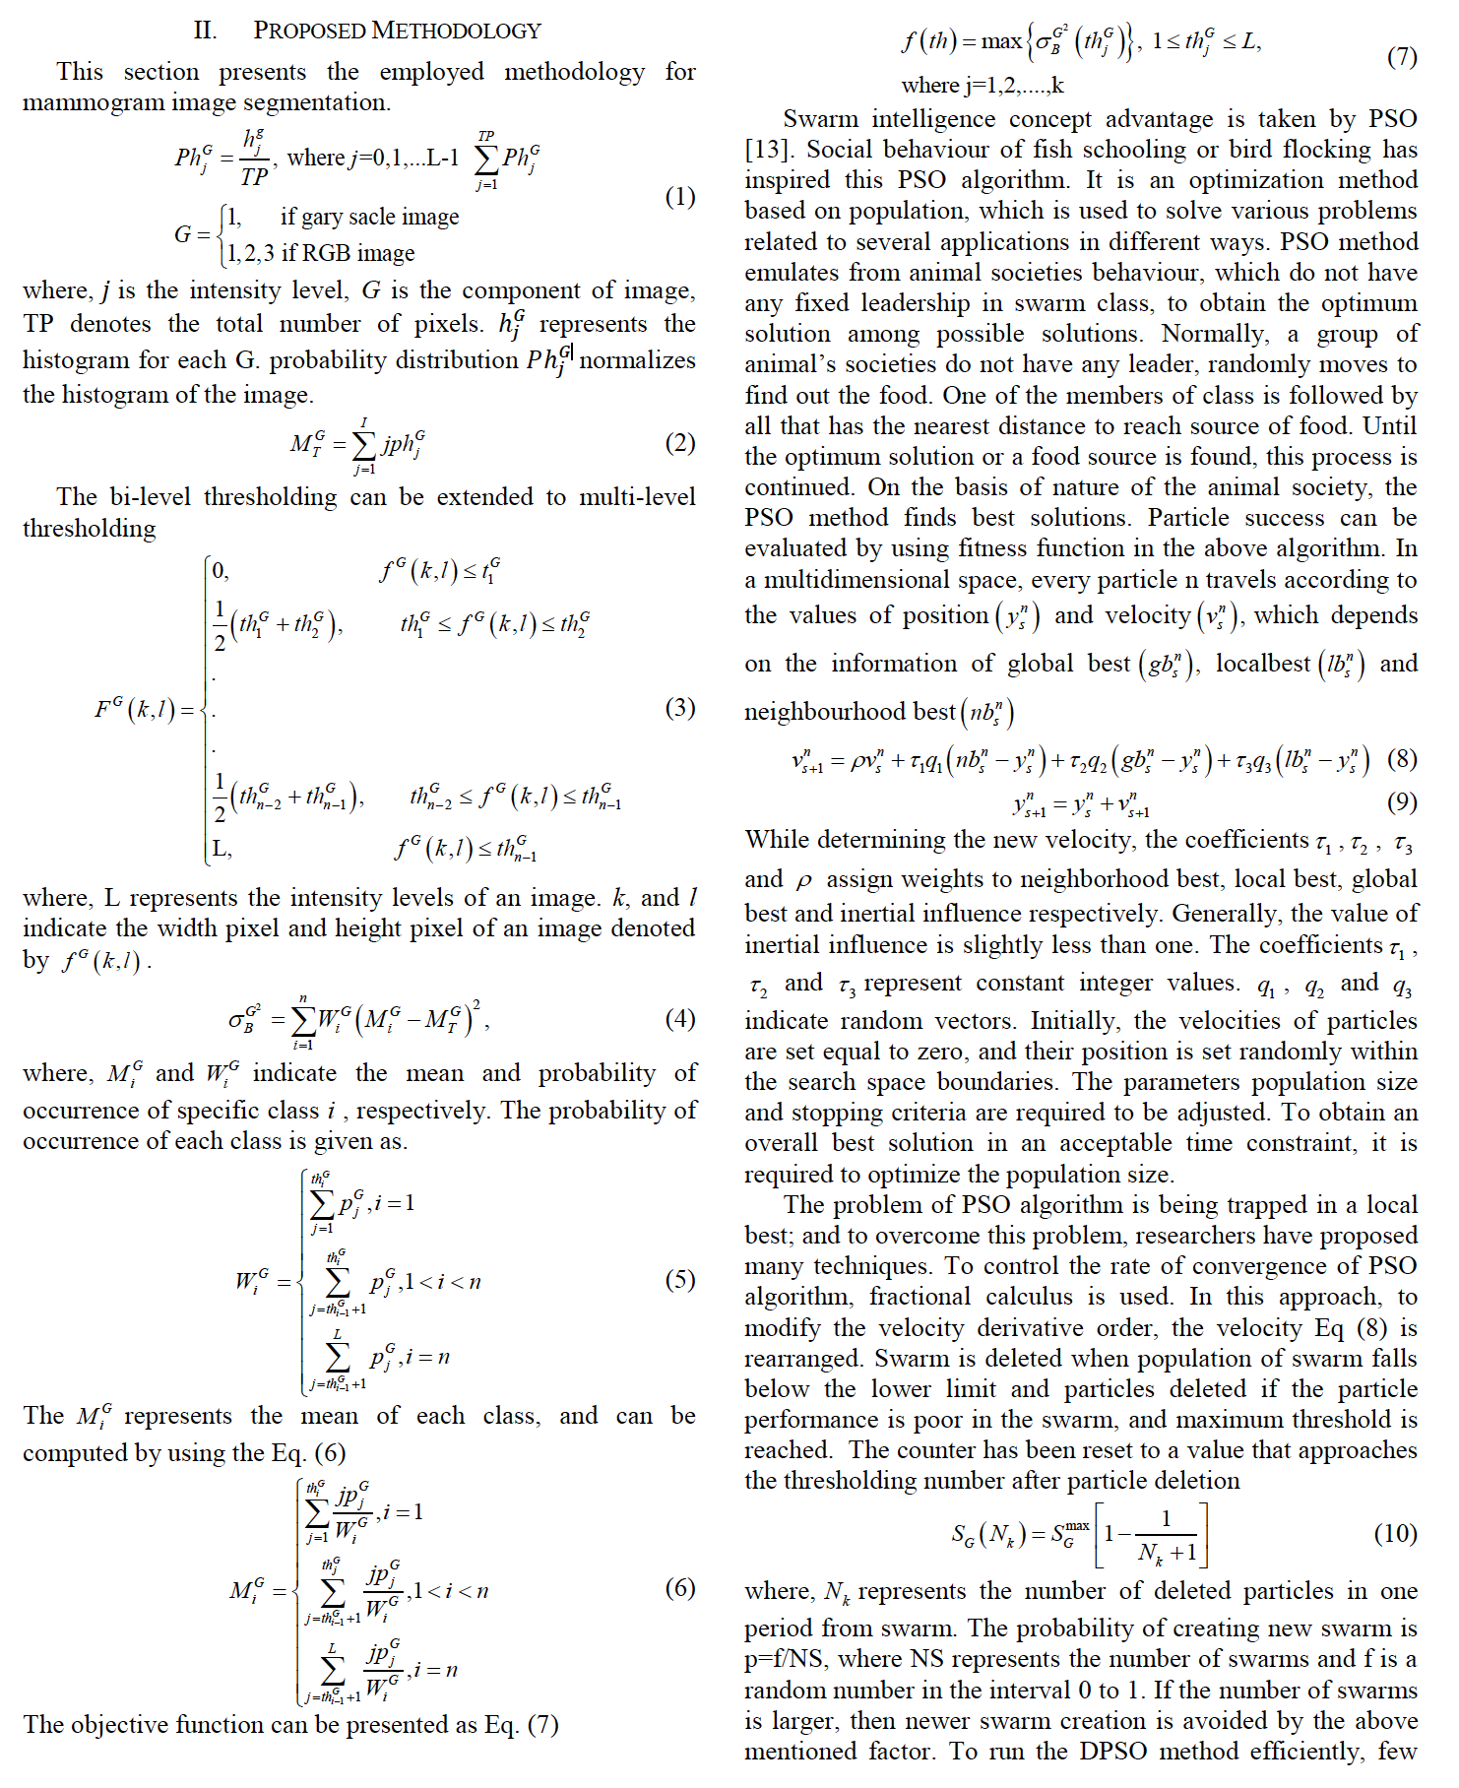

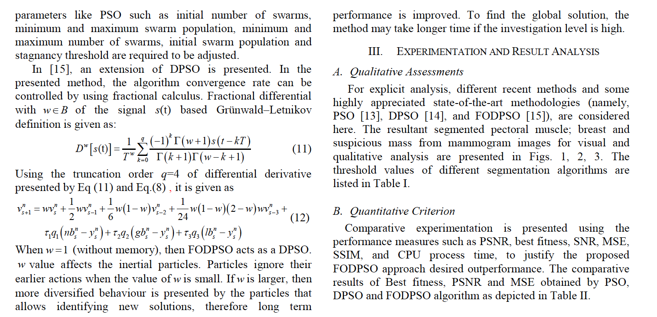

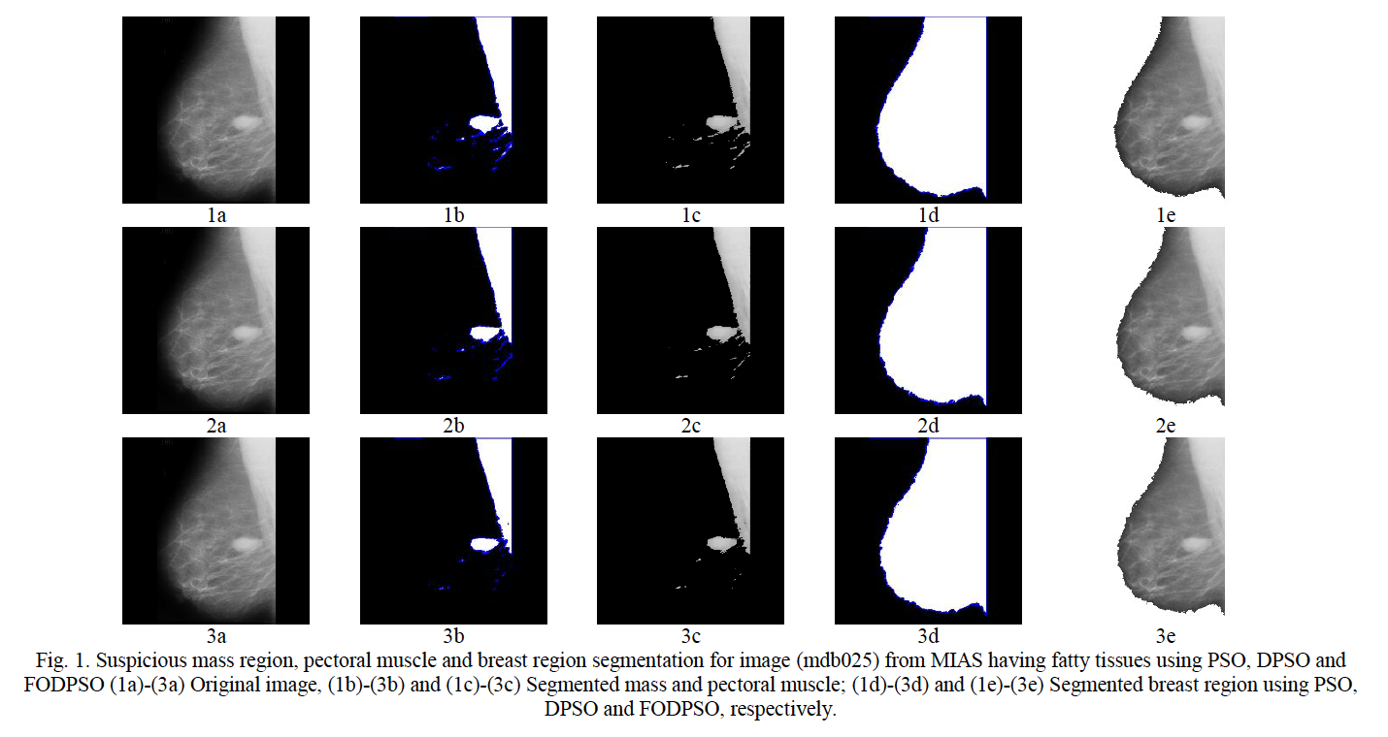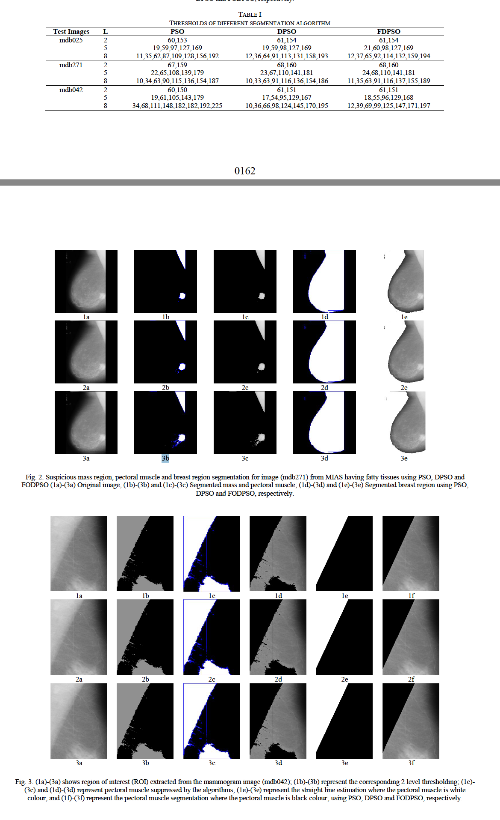

In this work, **fractional-order Darwinian particle swarm optimization (FODPSO) is employed and suggested to segment the pectoral muscle, breast and suspicious mass, efficiently.** In order to obtain **the optimal threshold values, the objective function of multilevel thresholding method, Otsu’s cost function is given as input to FODPSO, DPSO and**

**PSO.** The proposed technique is applied to all the images in MIAS database successfully. The performance of PSO, DPSO and FODPSO are compared successfully by using the performance metrics such as PSNR, SNR, SSIM, best fitness value and MSE. It is concluded that the **efficiency of FODPSO is superior to DPSO and PSO.** When segmentation levels increases, FODPSO becomes more efficient than the other two segmentation techniques. Some new optimization techniques can be applied to segment the bio-medical images in future, and much better results can be anticipated.

**Computational mammography using deep neural networks**

**A. Dubrovinaa, P. Kisilevb, B. Ginsburgc, S. Hashoulb,d and R. Kimmela**

**aComputer Science, Technion, Haifa, Israel; bIBM Haifa Research Lab, Haifa, Israel; cNVIDIA,Santa Clara, CA, USA; dCarmel Medical Center, Haifa, Israel**

**Abstract:**

Here, we present a novelsupervised Convolutional Neural Network (CNN)-based method for breast tissue classification from mammogram images.

**Problem Statement:**

Given a digital mammography image, we wish to associate each of its pixels with one of the **four following classes: pectoral muscle, fibroglandular tissue, nipple, and the general breast tissue,** which includes fatty tissue and skin. **Our data-set consists of 40 digital mammograms of mediolateral oblique (MLO) view, manually segmented by an expert into the four regions.** While the images include a significant portion of background pixels, these pixels are easily detected in a **pre-processing step, by thresholding image intensity values with zero threshold.**

**Breast tissue classification with DNN:**

DNNs can provide discriminative image representations, sometimes referred to as features, by **successive application of linear filters, non-linear activation functions, normalisation, and pooling operations, thus, avoiding the need to design such features manually.** The proposed DNN classifier, applied to raw image pixels, provides the probability of each pixel to belong to one of the four classes described above: **Pr(class(p) = k), k = 0, 1, 2, 3.** The DNN is applied in a patch-wise manner: to classify the pixel p, the DNN is fed with a square image patch of size w Å~ w, centred at p. In our experiments, we set w = 61 pixels. **The patches are pre-processed prior to training and classification, to have a zero mean, by subtracting from them the mean of all patches in the training set. The classification accuracy is acquired by a multinomial logistic loss function.**

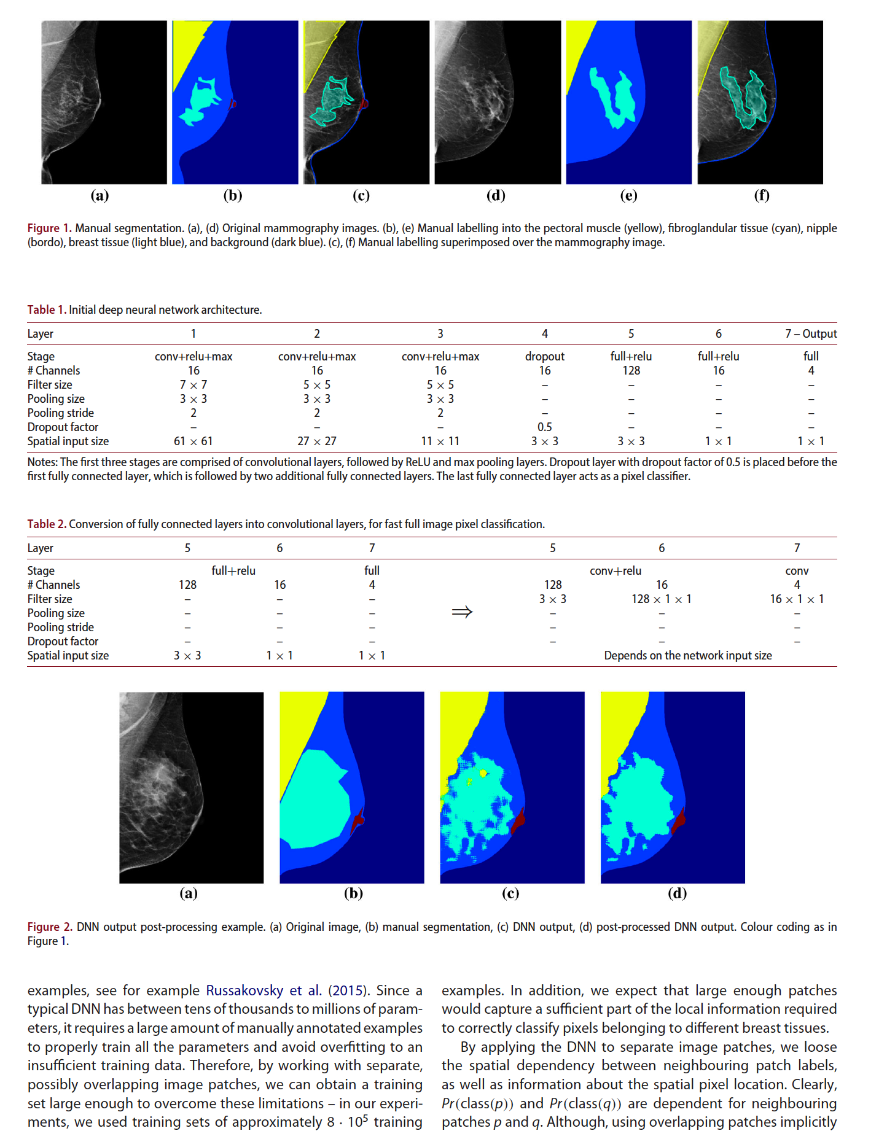

**Architecture**

It consists of three stages of convolutional layers, ReLU (rectified linear unit) activation layers, and max pooling layers, followed by three fully connected layers. To prevent overfitting, a dropout layer (Srivastava et al. 2014) with dropout factor of 0.5 was added between the convolutional and the fully connected layers. The image intensity and the normalised coordinate information can be combined after the first fully connected layer in the following manner: the two normalised patch centre coordinates and the 128-dimensional fifth layer output are concatenated into a 130-dimensional vector, passed to the second fully connected layer.

**Fast full image pixel classification**

During the classification stage, the network must be applied separately to all the **overlapping image patches**. This introduces a significant computation overhead, since both the convolutional layers, and the fully connected layers are applied multiple times to overlapping regions. we converted the proposed classification network into a **fully convolutional network.** That is, we converted the fully connected **layers #5, 6, 7, into convolutional layers,** as shown in Table 2. ***The new network is able to output dense predictions for input images of arbitrary sizes.*** Specifically, for the 829 x 640 images we used in our experiments, the new network output was 97 x 73. To obtain dense prediction for the whole image, we adopt the shift-and-stitch method of In the proposed network, **the outputs were downsampled by a factor of 8 with respect to inputs.** Hence, by feeding the new network shifted versions of the input, **by i ∈ {0, 1, . . . , 7} pixels right and j ∈ {0, 1, . . . , 7} pixels down,** and **interlacing the obtained 64 output images,** we obtain a **dense prediction for the whole image.** The classification time of the new network is approximately 1.8 seconds as opposed to 114 seconds for the **per-patch neural network application.** Conversion to the fully connected network requires the following adjustment. Previously, the mean of all training examples was subtracted from the network input during the training and the classification. Now, a single value is subtracted from the training examples at the training stage, and **from the entire image at the classification stage, allowing a full-image classification.** In our experiments, this change had a minor effect on the classification accuracy. We used a single mean intensity value of the pixels in the mean image, computed over all the training examples

**Classifier output post-processing**

The raw DNN classifier output obtained for one of the images in our data-set is shown in Figure 2(c). Since the proposed patchbased classifier cannot incorporate constraints in relative spatial locations of different tissues, it may produce fragmented regions, as shown in Figure 2(c). Therefore, during the post-processing step, as dictated by the physiological breast structure, (i) the interior of the large pectoral muscle region adjacent to origin of the image is filled with its corresponding label, while small unconnected components of the pectoral muscle region are given the label of the general breast tissue; (ii) the outer boundary of the fibrogladular tissue region is morpholocally filled to contain the fibrogladular tissue label, and its connected components smaller than some predefined threshold, are removed; (iii) a single connected component of the nipple region, closest to the centre of the image, is retained.

**Segmentation results**

**Pre-processing**

**In our experiments, we used a data-set with 40 manually segmented MLO views. All images were aligned so that the pectoral muscle appeared on the left side of the image, for spatial consistency. A leave-one-subject-out cross validation procedure was used. We considered different 40 imagesets with 39 training images, and the remaining image was used to evaluate the classification performance. The results presented below were averaged over all 40 possible training and test image combinations. Approximately 800,000 patches were extracted to form the training set, containing an equal number of patches centred at pixels belonging to the four different regions.**

**Network training**

**The DNN was trained by stochastic gradient descent with**

**momentum. We used mini batches of 256 image patches, and**

**learning rate of 10−3, reduced by a factor of 10 twice, after 30,000**

**and 60,000 training iterations (approximately 10 and 20 epochs).**

**We used momentum 0.9,weight decay 5.10−4, and initialised the**

**netweights randomly, using normal distribution with zero mean**

**and 0.01 and 0.1 variances for the convolutional and the fully**

**connected layers, respectively. During testing, the dropout layer**

**was removed, and the outputs of the layer #3 were multiplied by**

**a factor of 0.5.**

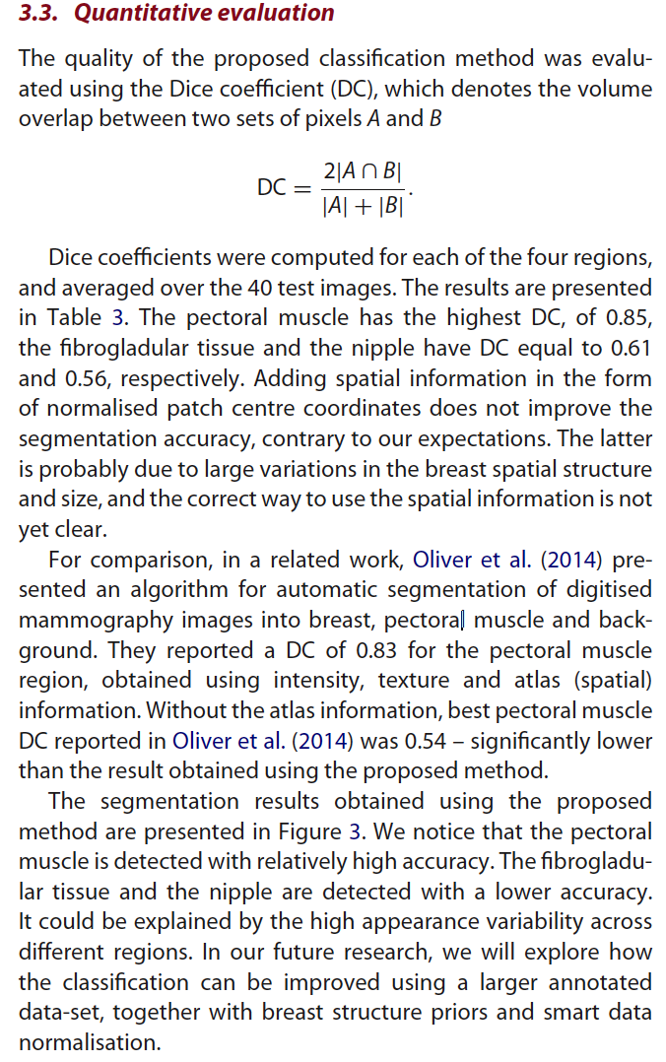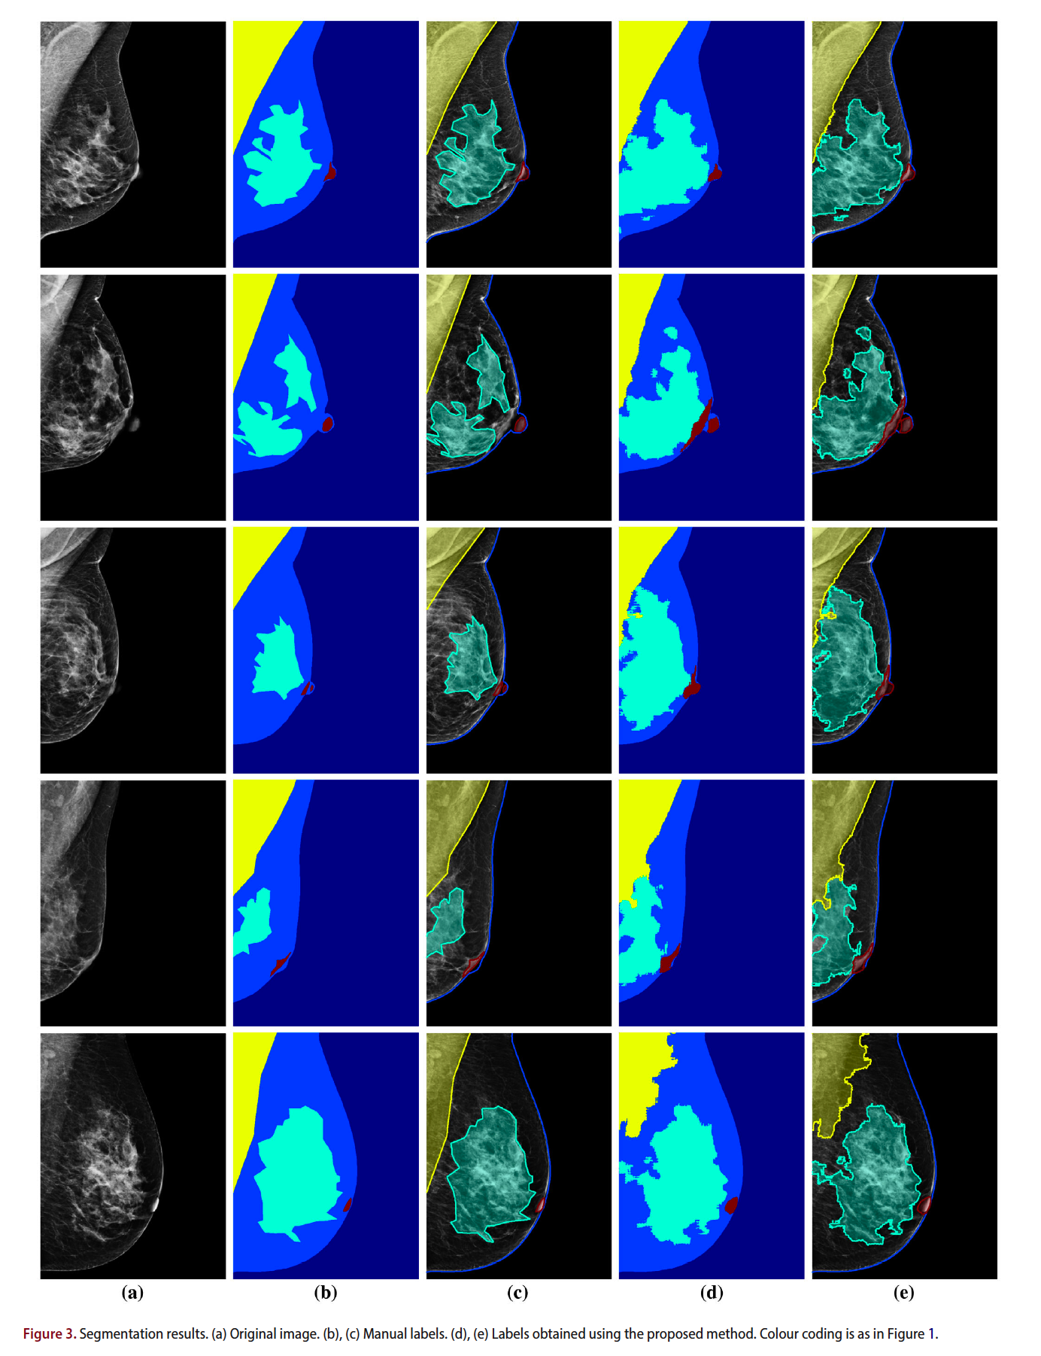

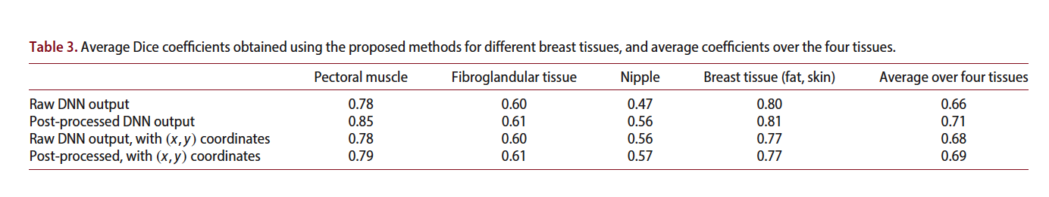

**ADVERSARIAL DEEP STRUCTURED NETS FOR MASS SEGMENTATION FROM MAMMOGRAMS**

**Wentao Zhu Xiang Xiang† Trac D. Tran† Gregory D. Hager† Xiaohui Xie**

**ABSTRACT**

Mass segmentation provides effective morphological features which are important for mass diagnosis. In this work, we propose **a novel end-to-end network for mammographic mass segmentation which employs a fully convolutional network (FCN) to model a potential function, followed by a conditional random field (CRF) to perform structured learning.** Because the mass distribution varies greatly with pixel position, the FCN is combined with a position priori. Further, we employ adversarial training to eliminate over-fitting due to the small sizes of mammogram datasets**. Multi-scale FCN is employed to improve the segmentation performance**. Experimental results on two public datasets, **INbreast** and **DDSMBCRP**, demonstrate that our end-to-end network achieves better performance than state-of-the-art approaches.

**Dataset**

**INBreast and DDSM-BCRP**

**Work:**

In this work, we propose an end-to-end trained adversarial deep structured network to perform mass segmentation (Fig.1). The proposed network is designed to robustly learn from a small dataset with **poor contrast mammographic images.**

Specifically, **an end-to-end trained FCN with CRF is applied**. Adversarial training is introduced into the network to learn robustly from scarce mammographic images. **we directly optimize pixel-wise labeling loss.** To further explore statistical

property of mass regions, **a spatial priori is integrated into FCN**. We validate the adversarial deep structured network on two public mammographic mass segmentation datasets. The proposed network is demonstrated to outperform other algorithms for mass segmentation consistently.Our main contributions in this work are: **(1) We propose an unified end-to-end training framework integrating FCN+CRF and adversarial training. (2) We employ an end-to-end network to do mass segmentation while previous works require a lot of hand-designed features or multi-stage training. (3) Our model achieves the best results on two most commonly used mammographic mass segmentation datasets.**

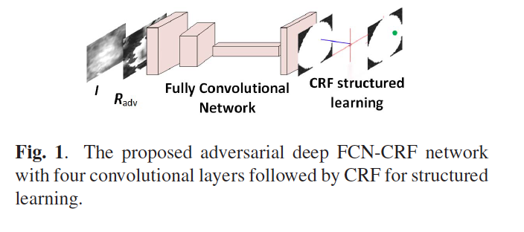

**FCN-CRF NETWORK**

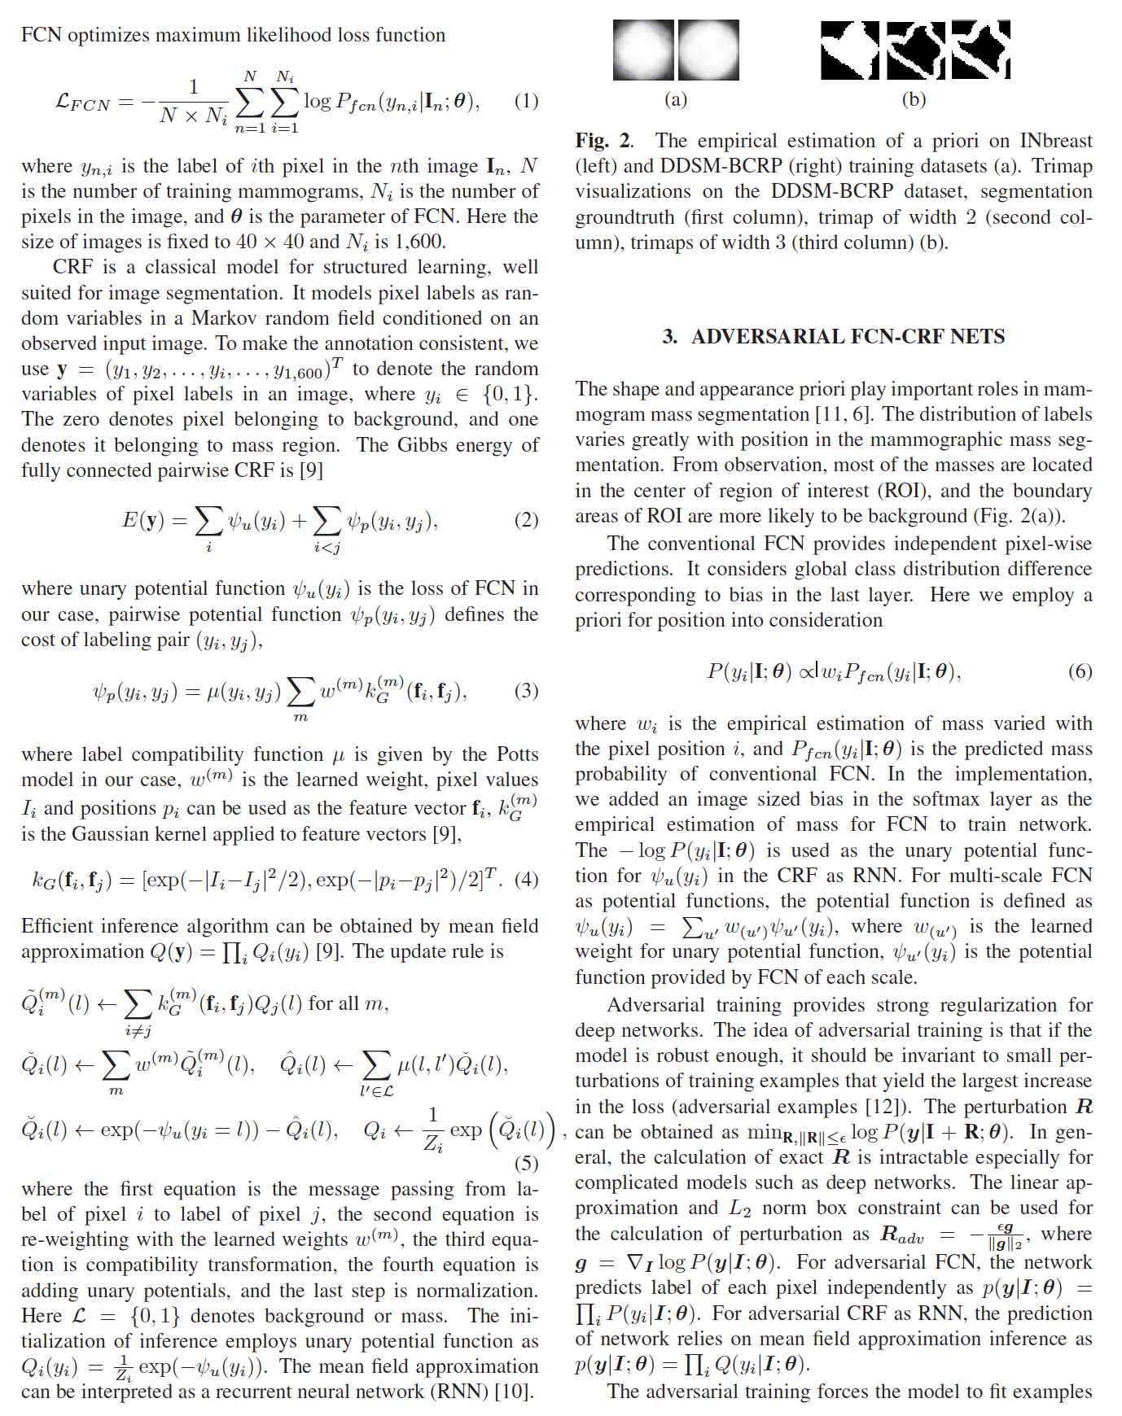

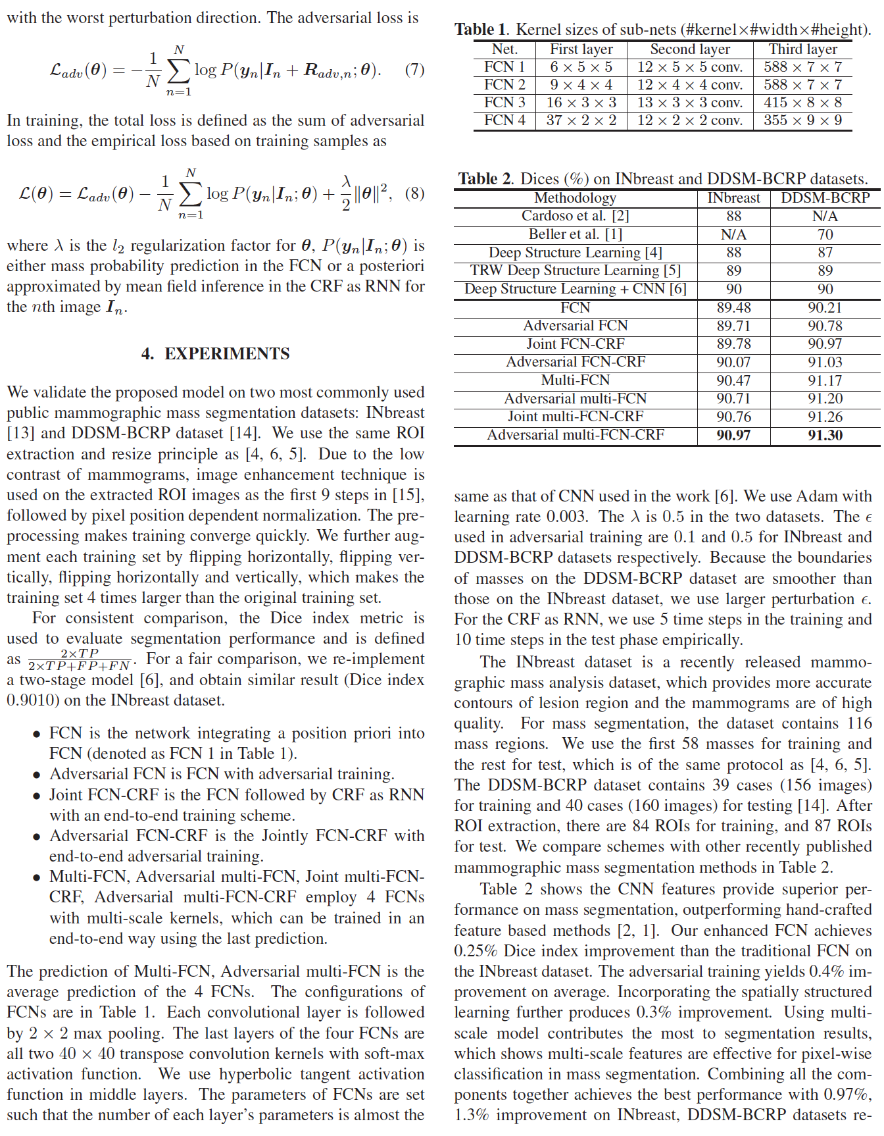

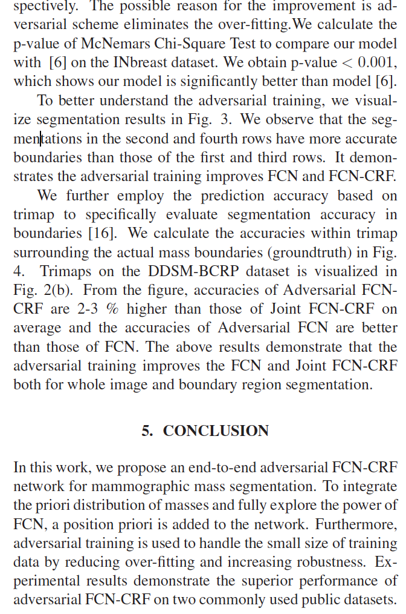

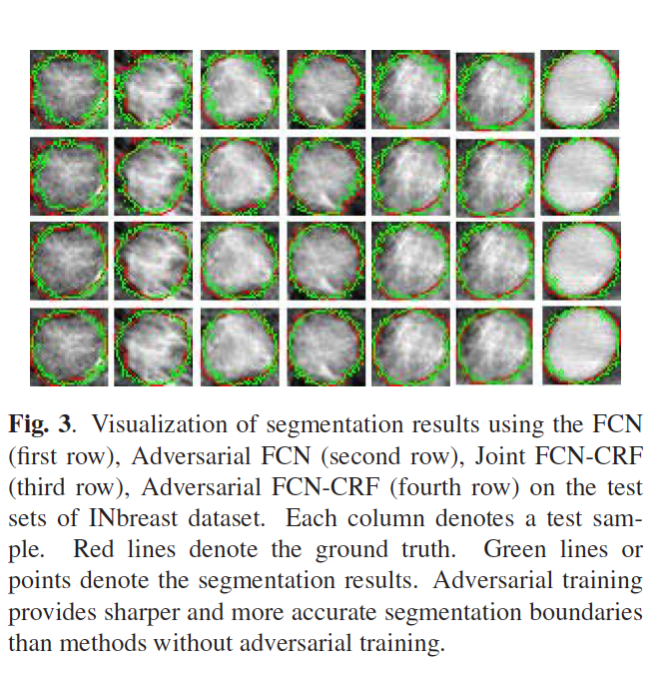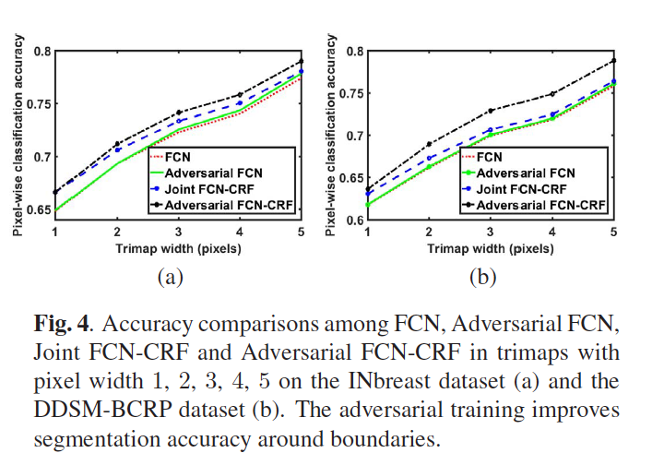

**Automated Analysis of Unregistered Multi-View Mammograms With Deep Learning**

Gustavo Carneiro, Jacinto Nascimento, and Andrew P. Bradley

**Abstract**

We describe an automated methodology for the analysis of **unregistered cranio-caudal (CC) and medio- lateral oblique (MLO)** mammography views in order to estimate the patient’s risk of developing breast cancer. The main innovation behind this methodology lies in the use of deep learning models for the problem of jointly classifying unregistered mammogram views and respective segmentation maps of breast lesions (i.e., masses and micro-calcifications). This is a holistic methodology that can classify a whole mammographic exam, containing the CC and MLO views and the segmentation maps, as opposed to the classification of individual lesions, which is the dominant approach in the field. We also demonstrate that the proposed system is capable of **using the segmentation maps generated by automated mass and microcalcification detection systems, and still producing accurate results**. The semi-automated approach (using manually defined mass and microcalcification segmentation maps) is tested on two publicly available data sets (**INbreast and DDSM**), and results show that the **volume under ROC surface (VUS)** for a 3-class problem **(normal tissue, benign, and malignant)** is over **0.9,** the **area under ROC curve (AUC) for the 2-class “benign versus malignant” problem is over 0.9,** and for the **2-class breast screening problem (malignancy versus normal/benign) is also over 0.9**. For the fully automated approach, the **VUS** results on **INbreast is over 0.7, and the AUC for the 2-class “benign versus malignant” problem is over 0.78, and the AUC for the 2-class breast screening is 0.86.**

We propose a new methodology that analyses a **two-view mammographic exam in a fully automated and holistic manner.** The main innovation behind our approach is the use of a deep learning model that receives as **input, both the CC and MLO** mammographic views and the **segmentation maps of the breast lesions** (i.e., masses and MCs) and outputs **a classification of the exam into normal tissue, benign or malignant** (hereafter, we refer to the normal tissue class as negative). The proposed methodology faces the following challenges: **1) deep learning models need annotated datasets that are orders of magnitude larger than what is currently available in medical imaging, and 2) the joint analysis of unregistered multi-view (CC and MLO) and multi- modal inputs (images and segmentation maps) require high- level features that represent the global information present in those inputs.**

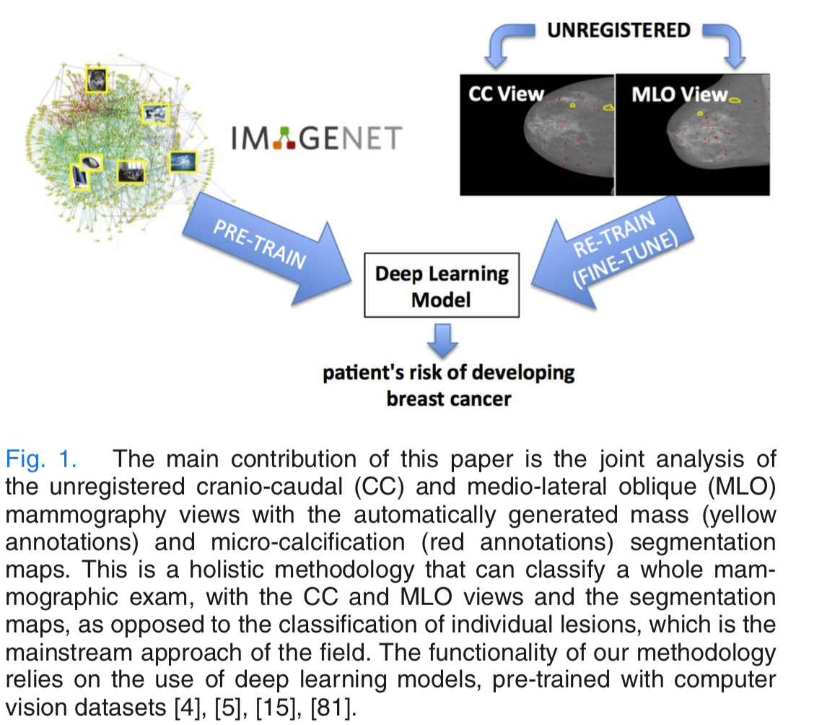

The first challenge is addressed with **transfer learning** where the deep learning model is **first trained with a large annotated computer vision dataset** , and then **re- trained (or fine-tuned) using small annotated mammogram datasets.**In parallel to the development of our own work, other similar approaches have been proposed, such as the use of ImageNet to pre-train a deep learning model that identifies pathologies in chest x-ray images, or the thorough study produced on the use of non-medical image datasets to pre-train deep learning models to be used in various medical image analysis tasks.

The second challenge is solved with the **use of the high-level features produced by the deep learning models**, where we assume that the high-level nature of the deep learning features reduces the need for a low-level matching (registration) of the input data. After the development of our original work, which is extended in this paper, there have been relatively similar proposals that classify whole or large patches of mammograms using deep learning models.In fact, We test two versions of our proposed methodology:

**A semi-automated** approach that uses the **manually defined seg- mentation maps of the lesions, and a fully automated approach that uses the lesion detection results** from Dhungel et al. [22] and Lu et al. [55]. Compared to previously proposed methods in the field, **our model is able to automatically learn the features that are optimal for the classification problem** (as opposed to hand-crafting them) **and to process a full mammographic exam in a holistic manner**, **without making lesion independence assumptions**. The semi-automated approach is assessed on two publicly available datasets (**INbreast and DDSM**), where it produces state of the art **results for the 3-class and 2-class classification problems.** The fully automated approach assessed on INbreast shows a competitive result with respect to the semi-automated approach on the same classification problems.

This paper is an extension of two preliminary works , where the innovations consist of: 1) **the fully automated methodology based on automatically detected masses and MCs, 2) a study on the stage of the deep learning model to merge the different modalities, 3) a study involving a larger set of data augmentation, and 4) a new way of joining the input images as 3-D inputs rather than a collection of 2-D data**.

In this paper, **the main novelty consists of the use of unregistered multi-view inputs, where images and segmentation maps are processed in a holistic manner** (our original paper on the holistic analysis was also developed in parallel to the approaches cited above - note that even though we use detection of lesions, we process the whole image and not each lesion independently). We also explore the transfer learning approaches mentioned above to deal with the limited amount of training samples.

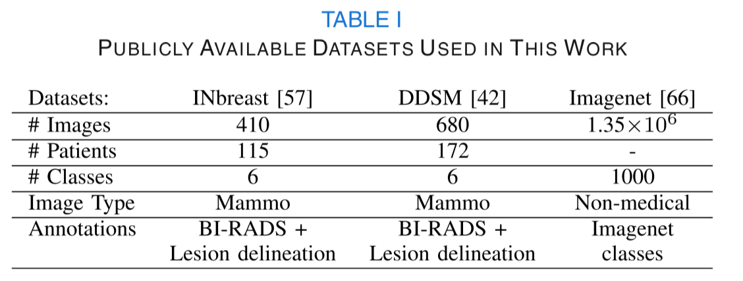

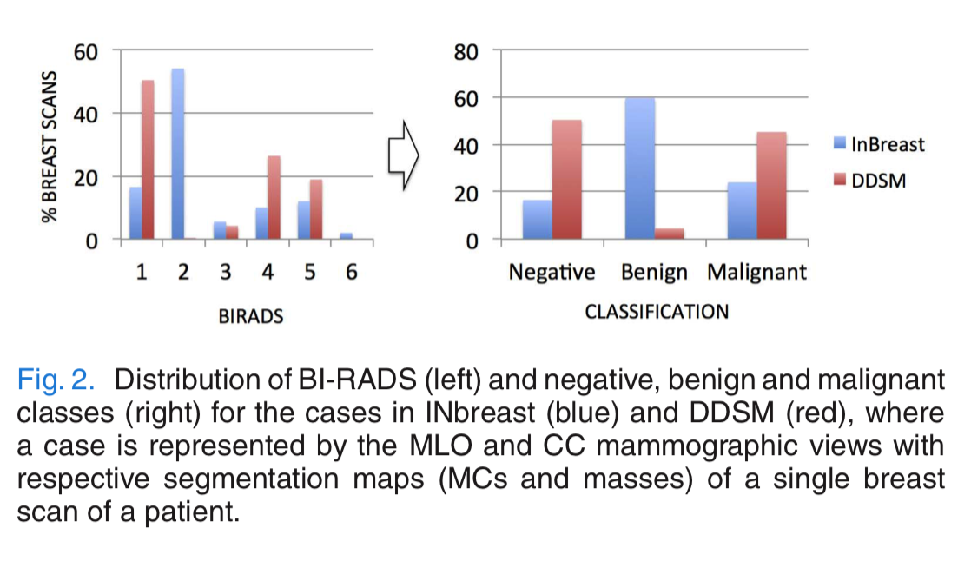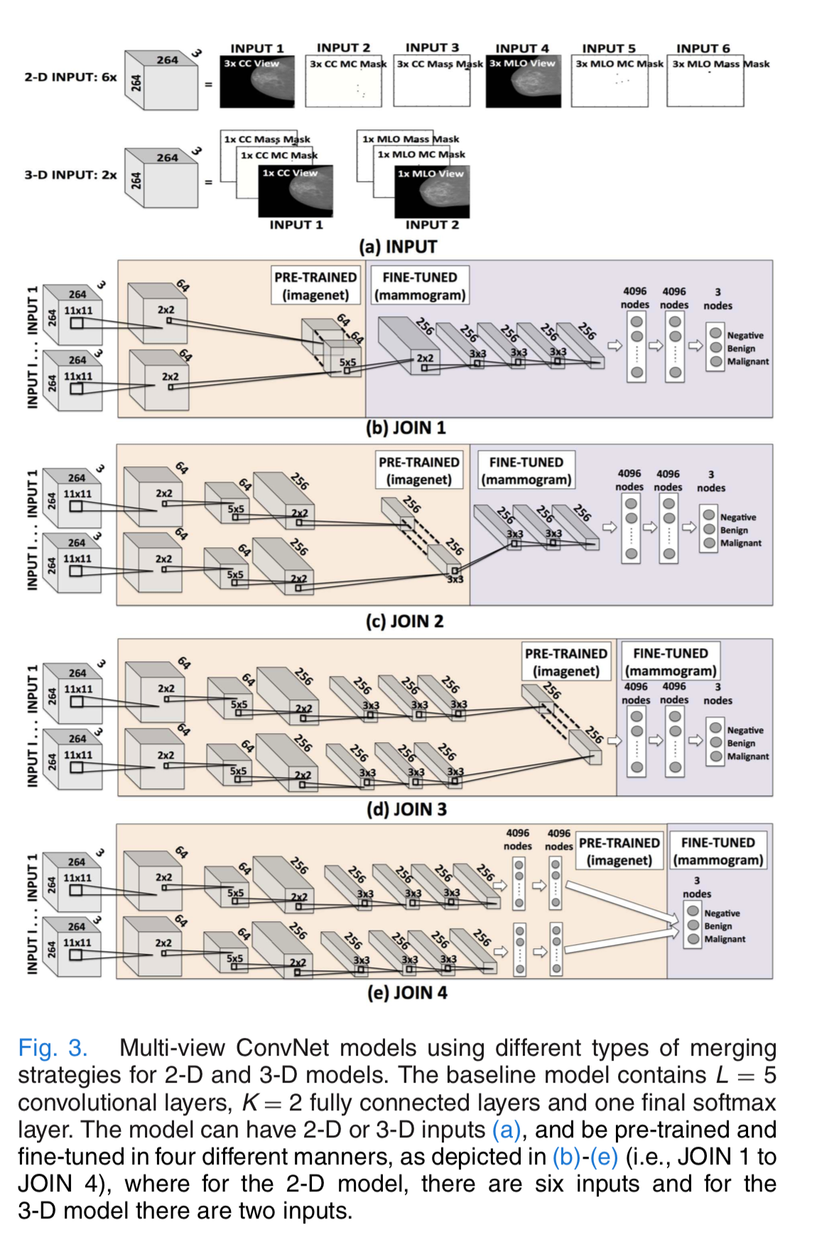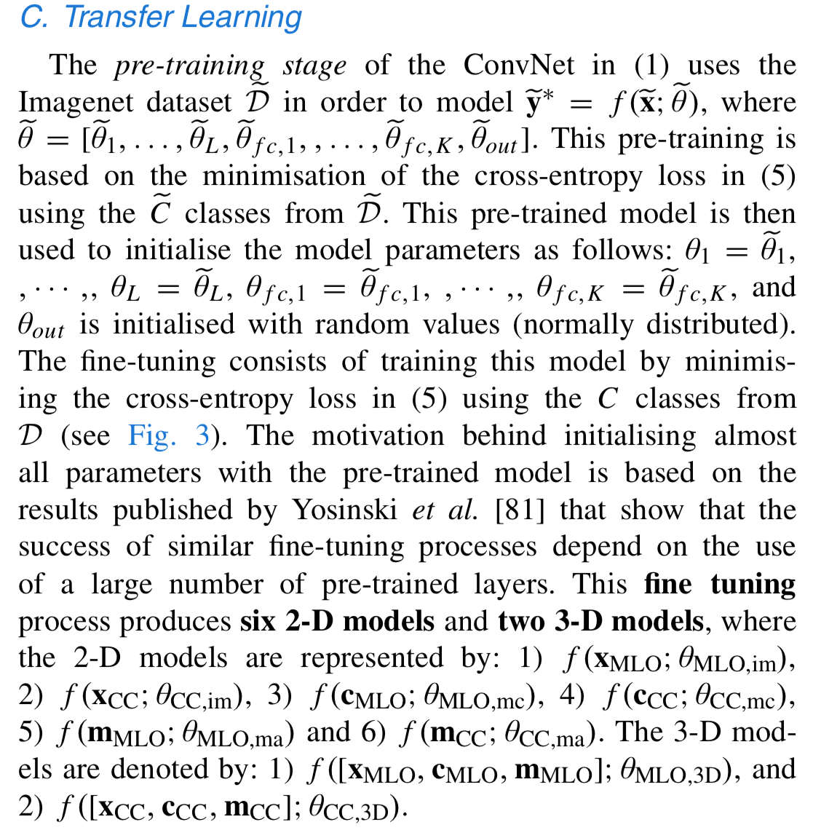 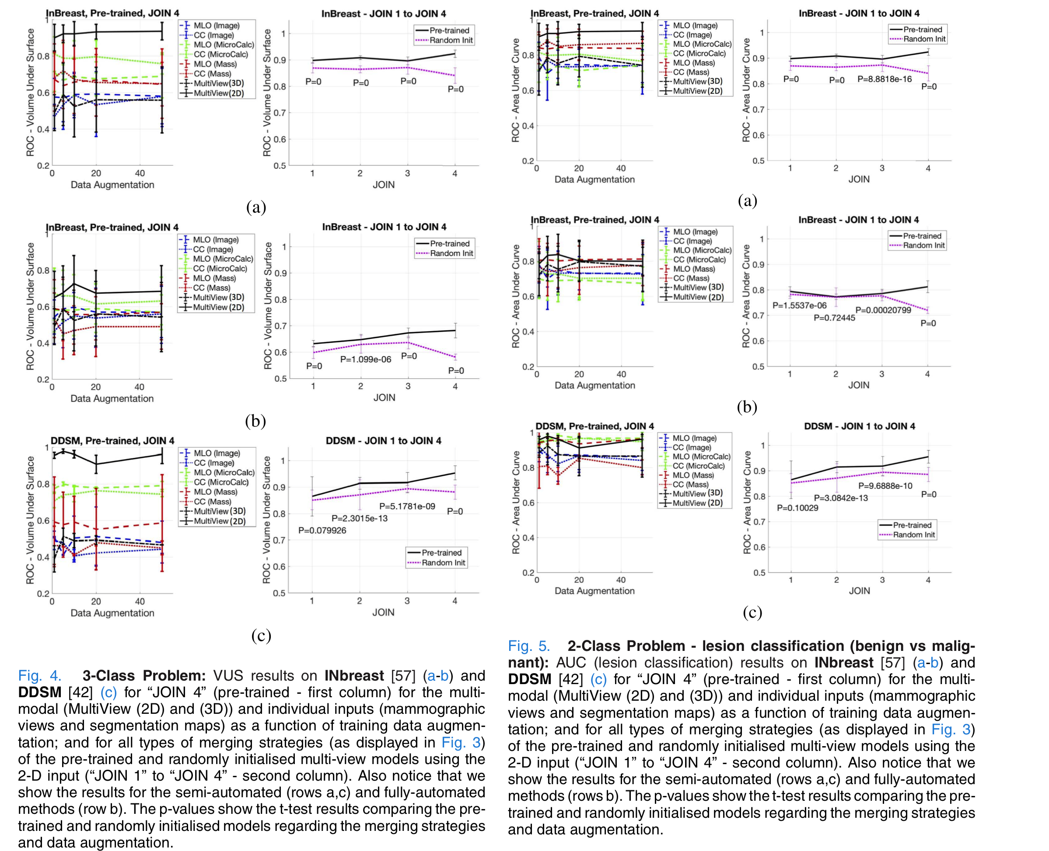

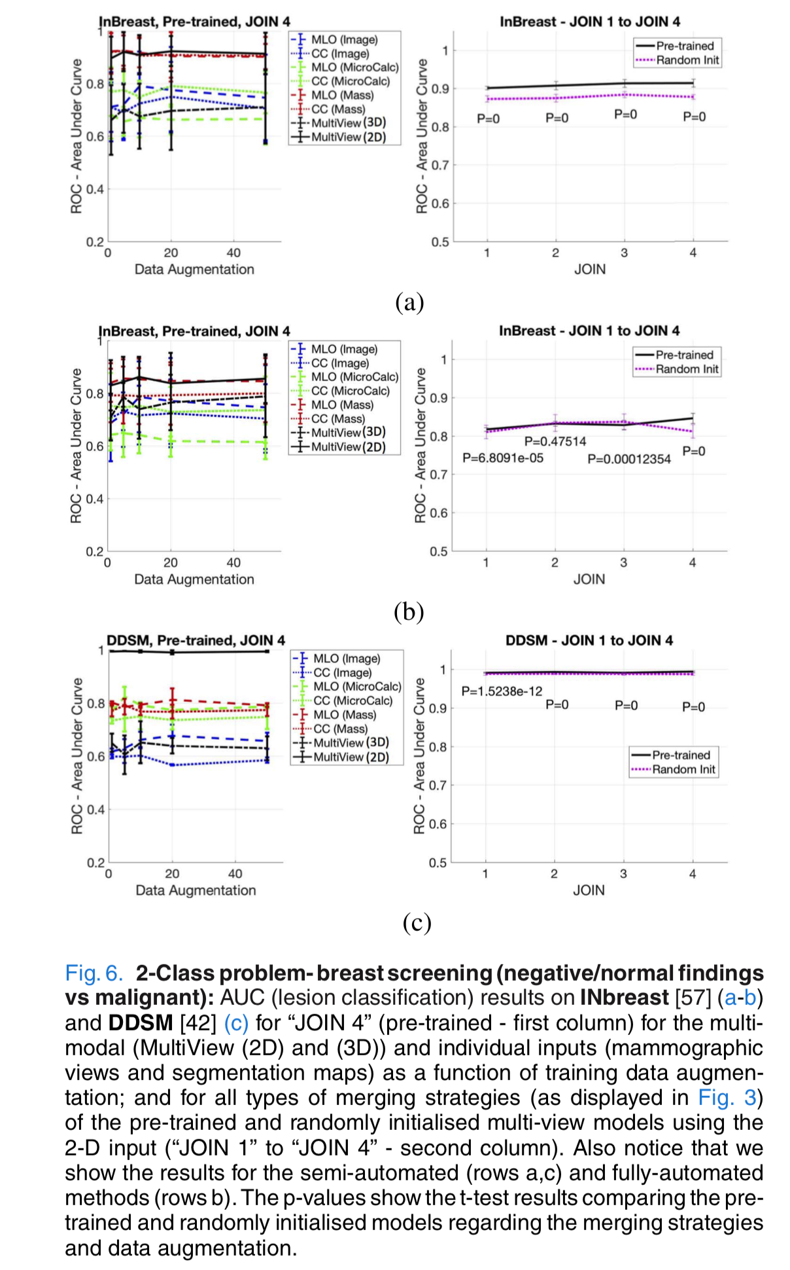

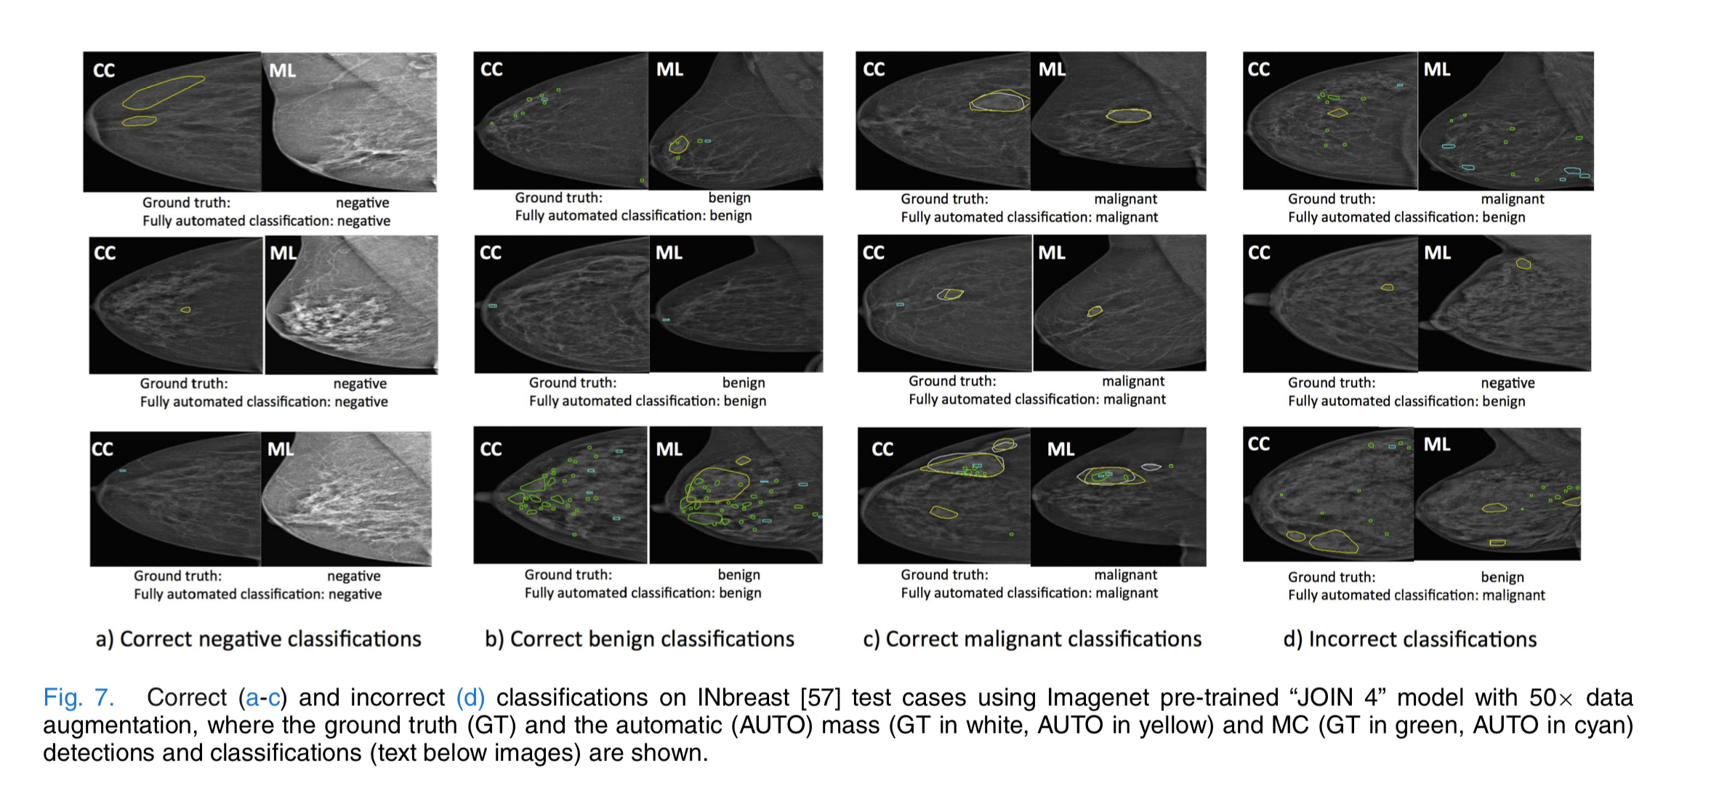

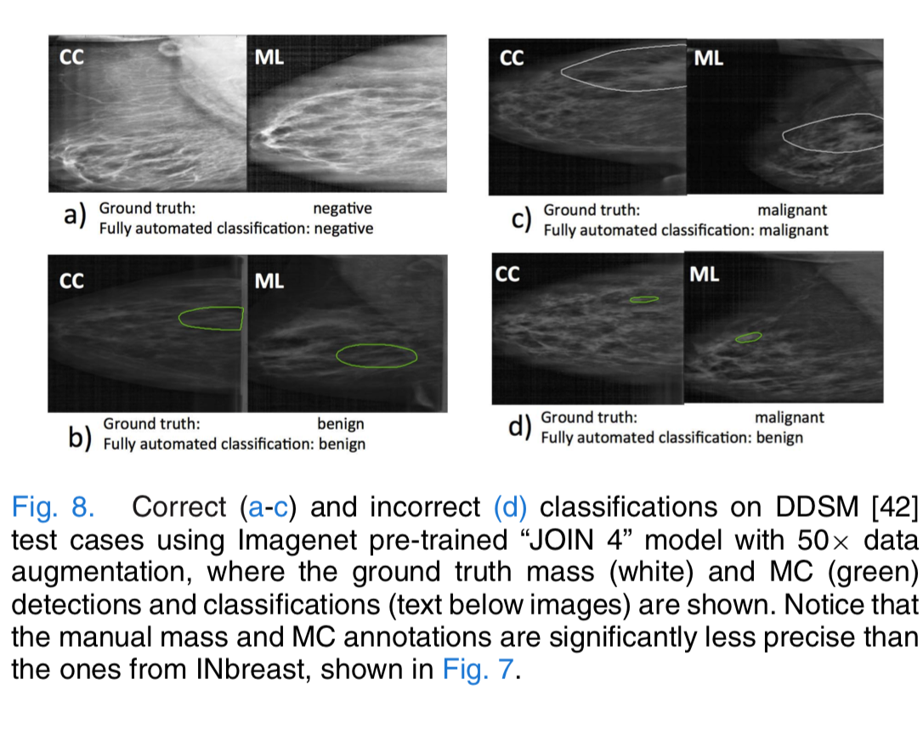

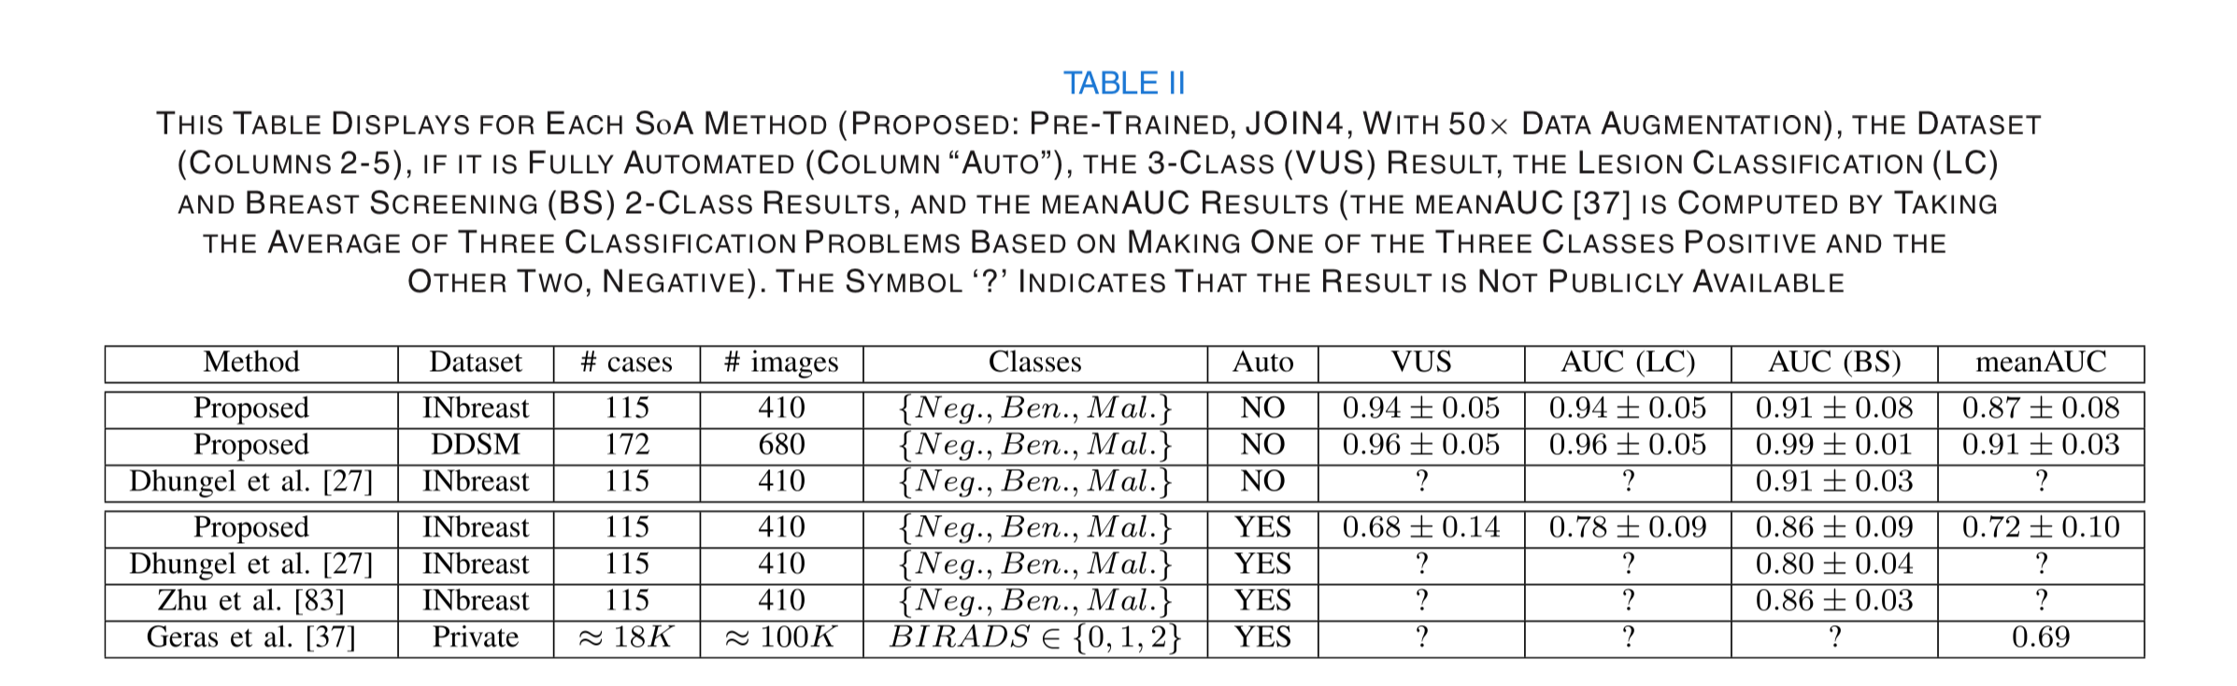

## [Preprocessing digital breast mammograms using adaptive weighted frost filter](http://www.biomedres.info/biomedical-research/preprocessing-digital-breast-mammograms-using-adaptive-weighted-frost-filter.html)

**Muhammad Talha**[**1**](http://www.biomedres.info/biomedical-research/preprocessing-digital-breast-mammograms-using-adaptive-weighted-frost-filter.html#a1)[**\***](http://www.biomedres.info/biomedical-research/preprocessing-digital-breast-mammograms-using-adaptive-weighted-frost-filter.html#corr)**, Ghazali Bin Sulong**[**2**](http://www.biomedres.info/biomedical-research/preprocessing-digital-breast-mammograms-using-adaptive-weighted-frost-filter.html#a2)**, Arfan Jaffar[3](http://www.biomedres.info/biomedical-research/preprocessing-digital-breast-mammograms-using-adaptive-weighted-frost-filter.html#a3)**

1Deanship of Scientific Research, King Saud University Riyadh Saudi Arabia

2Faculty of Computing, Universiti Teknologi Malaysia

3Department of Computer Science, Imam Muhammad Bin Saud Islamic University, Saudi Arabia

**Abstract**

Many techniques have been used to enhance image quality, image smoothing and noise restoration. The experimental results conclude that the proposed **Adaptive Weighted Frost filter i**s the best suitable choice for eliminating noise from mammographic images and performs better comparatively. The comparison of proposed technique with various existing techniques is performed both qualitatively and quantitatively. The experiments have demonstrated that the proposed technique provides better results as compare to existing techniques.

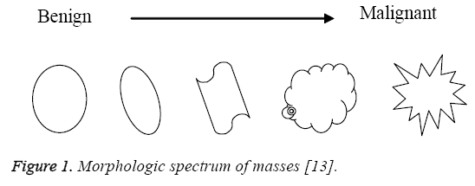

Sometimes it becomes quiet complicated to distinguish between benign and malignant masses because of low-contrast. So it is pertinent to apply any automatic technique to enhance the visual quality of mammographic image in order to forefront the malignancies, if exists. **Enhancing the contrast, extracting the features and removing the noise are the fundamental issues in mammograms which need to be addressed** [[14](http://www.biomedres.info/biomedical-research/preprocessing-digital-breast-mammograms-using-adaptive-weighted-frost-filter.html#14)]. Noise may be expressed as any change in the mammogram that do not relate to variations in the X-ray attenuation of the object being imaged. X-ray quantum noise is the significant type of no**ise which is denoted by a Poisson distribution** [[15](http://www.biomedres.info/biomedical-research/preprocessing-digital-breast-mammograms-using-adaptive-weighted-frost-filter.html#15)]. Such type of noise is generally introduced during mammograms image acquisition because of less number of x-ray photons. It reduces the contrast of the mammogram image mainly which results in the **low value of signal-to-noise ratio** (SNR) [[16](http://www.biomedres.info/biomedical-research/preprocessing-digital-breast-mammograms-using-adaptive-weighted-frost-filter.html#16)]. Resultantly, the contrast of mammogram**s becomes low because of quantum noise whose detection is not only a complicated job but also challenging for the radiologists. False-negatives for radiologist mammography interpretation vary from 10 to 30% due to different factors** [[17](http://www.biomedres.info/biomedical-research/preprocessing-digital-breast-mammograms-using-adaptive-weighted-frost-filter.html#17)].

Some existing methods on image enhancement are **median filtering, Frost filter, Wiener filter, histogram equalization and contrast limited adaptive histogram equalization.** The radiologist uses various softwares like **“ImageChecker” and “SecondLook”** to enhance and/or zoom the selected part of the mammograms which are usually based on various enhancement, segmentation/cropping and zooming techniques. For the enhancement of mammograms, Bhateja et al. [[18](http://www.biomedres.info/biomedical-research/preprocessing-digital-breast-mammograms-using-adaptive-weighted-frost-filter.html#18)] used median filter to suppress salt and pepper noise. For noise restoration, the average of three filters (**Frost, Adaptive Wiener and non-local mean)** was proposed by Naveed et al. [[19](http://www.biomedres.info/biomedical-research/preprocessing-digital-breast-mammograms-using-adaptive-weighted-frost-filter.html#19)]. The mean value of these filters was replaced with noisy pixels. The authors implemented their technique on salt & pepper and quantum noise. They used **PSNR and SSIM** (structural similarity index measure) as performance measures to evaluate the performance of the proposed technique with various existing methods in literature. Numerous computer aided techniques for image processing have been developed and applied by many of researchers for the enhancement of mammographic images using various filters. In our proposed method, the **Frost filter is modified which intelligently remove the noise from the mammograms.**

## 

## **Materials and Methods**

**Adaptive weighted frost filter for quantum noise removal**

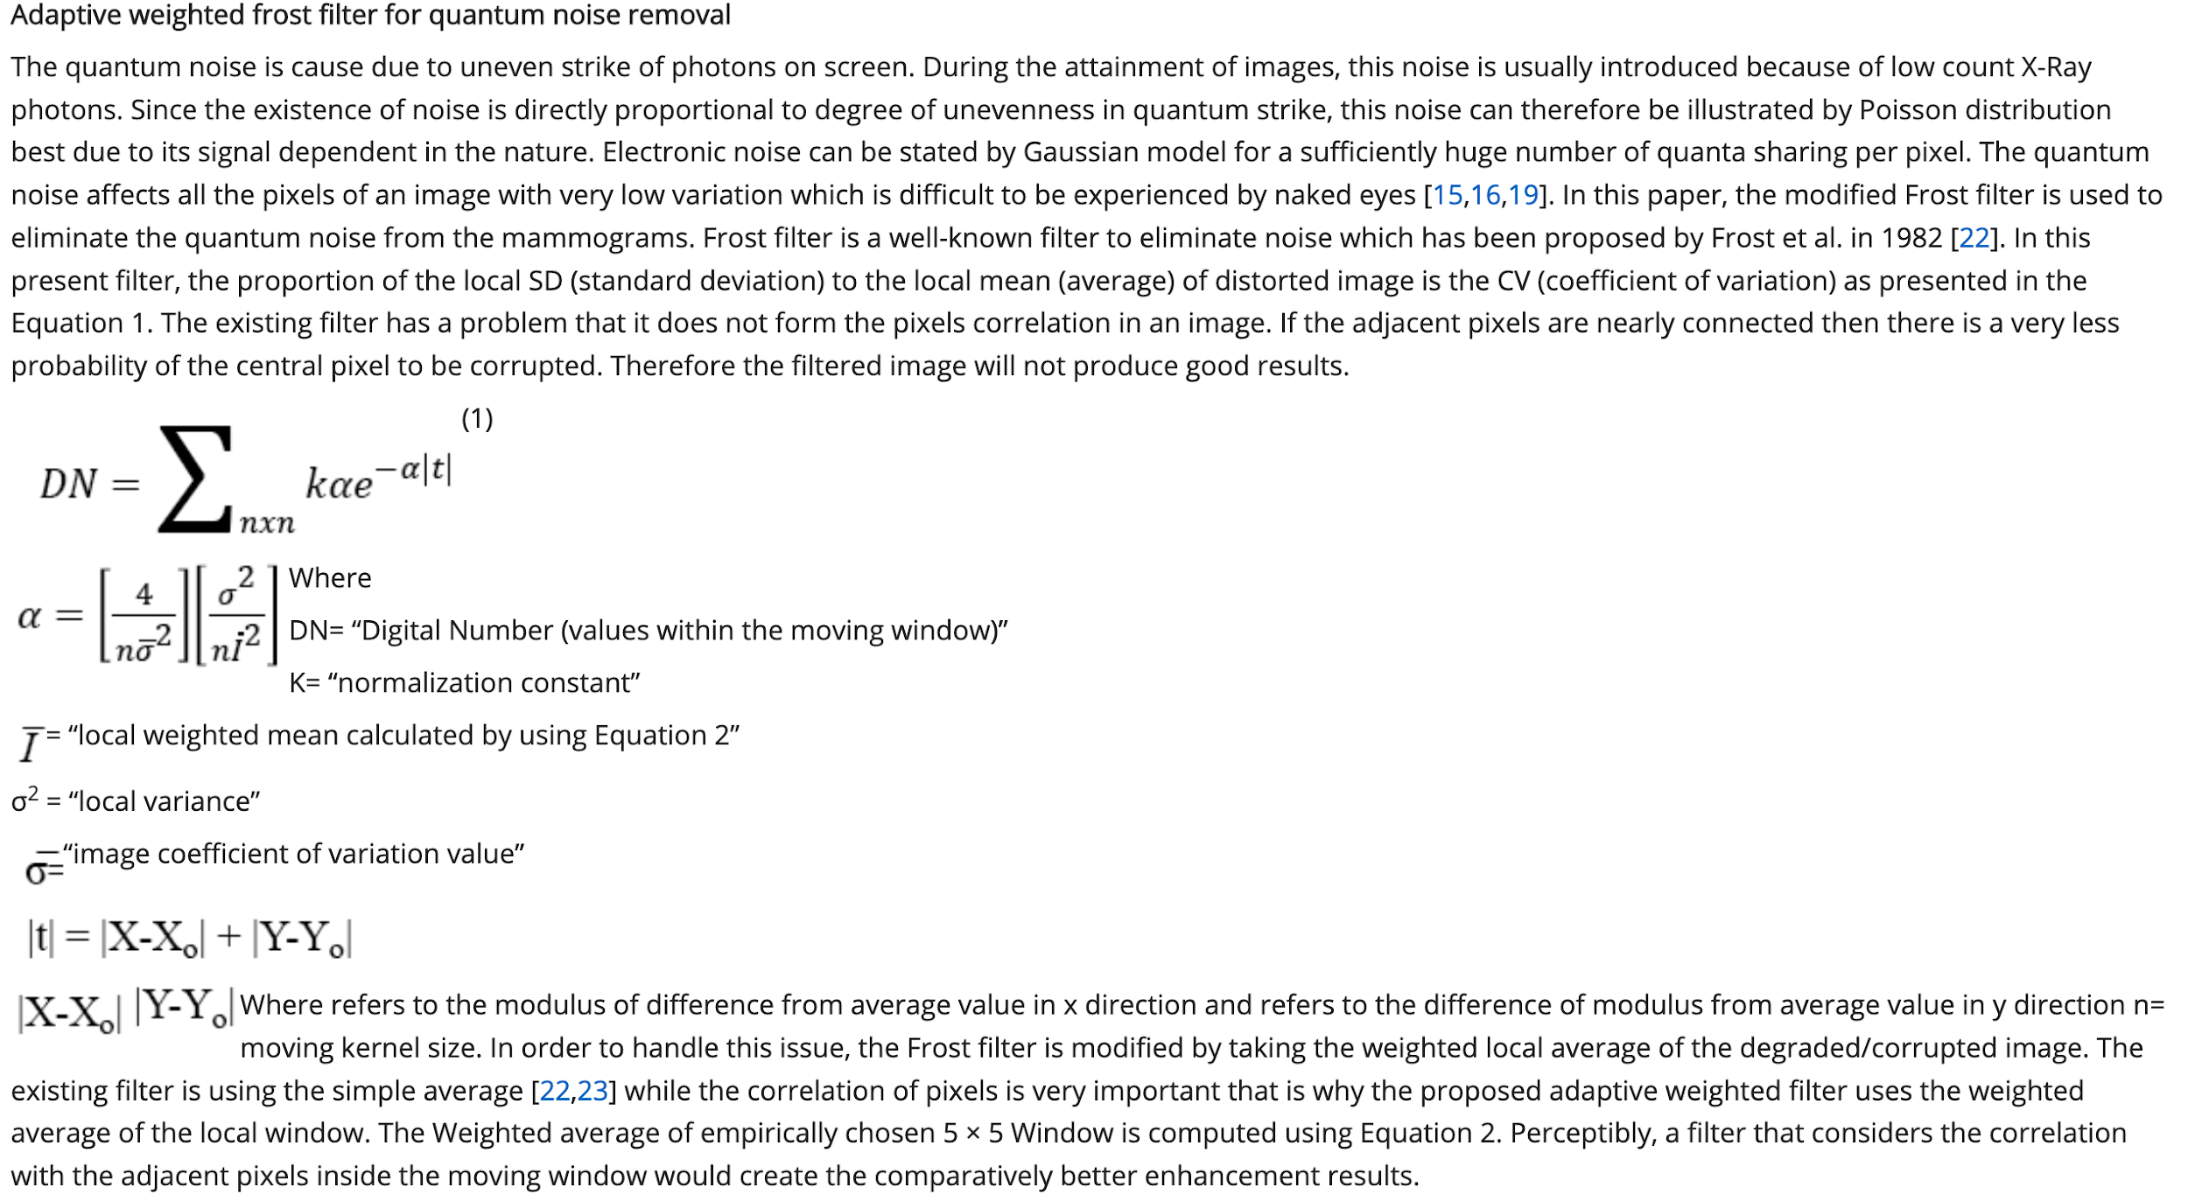

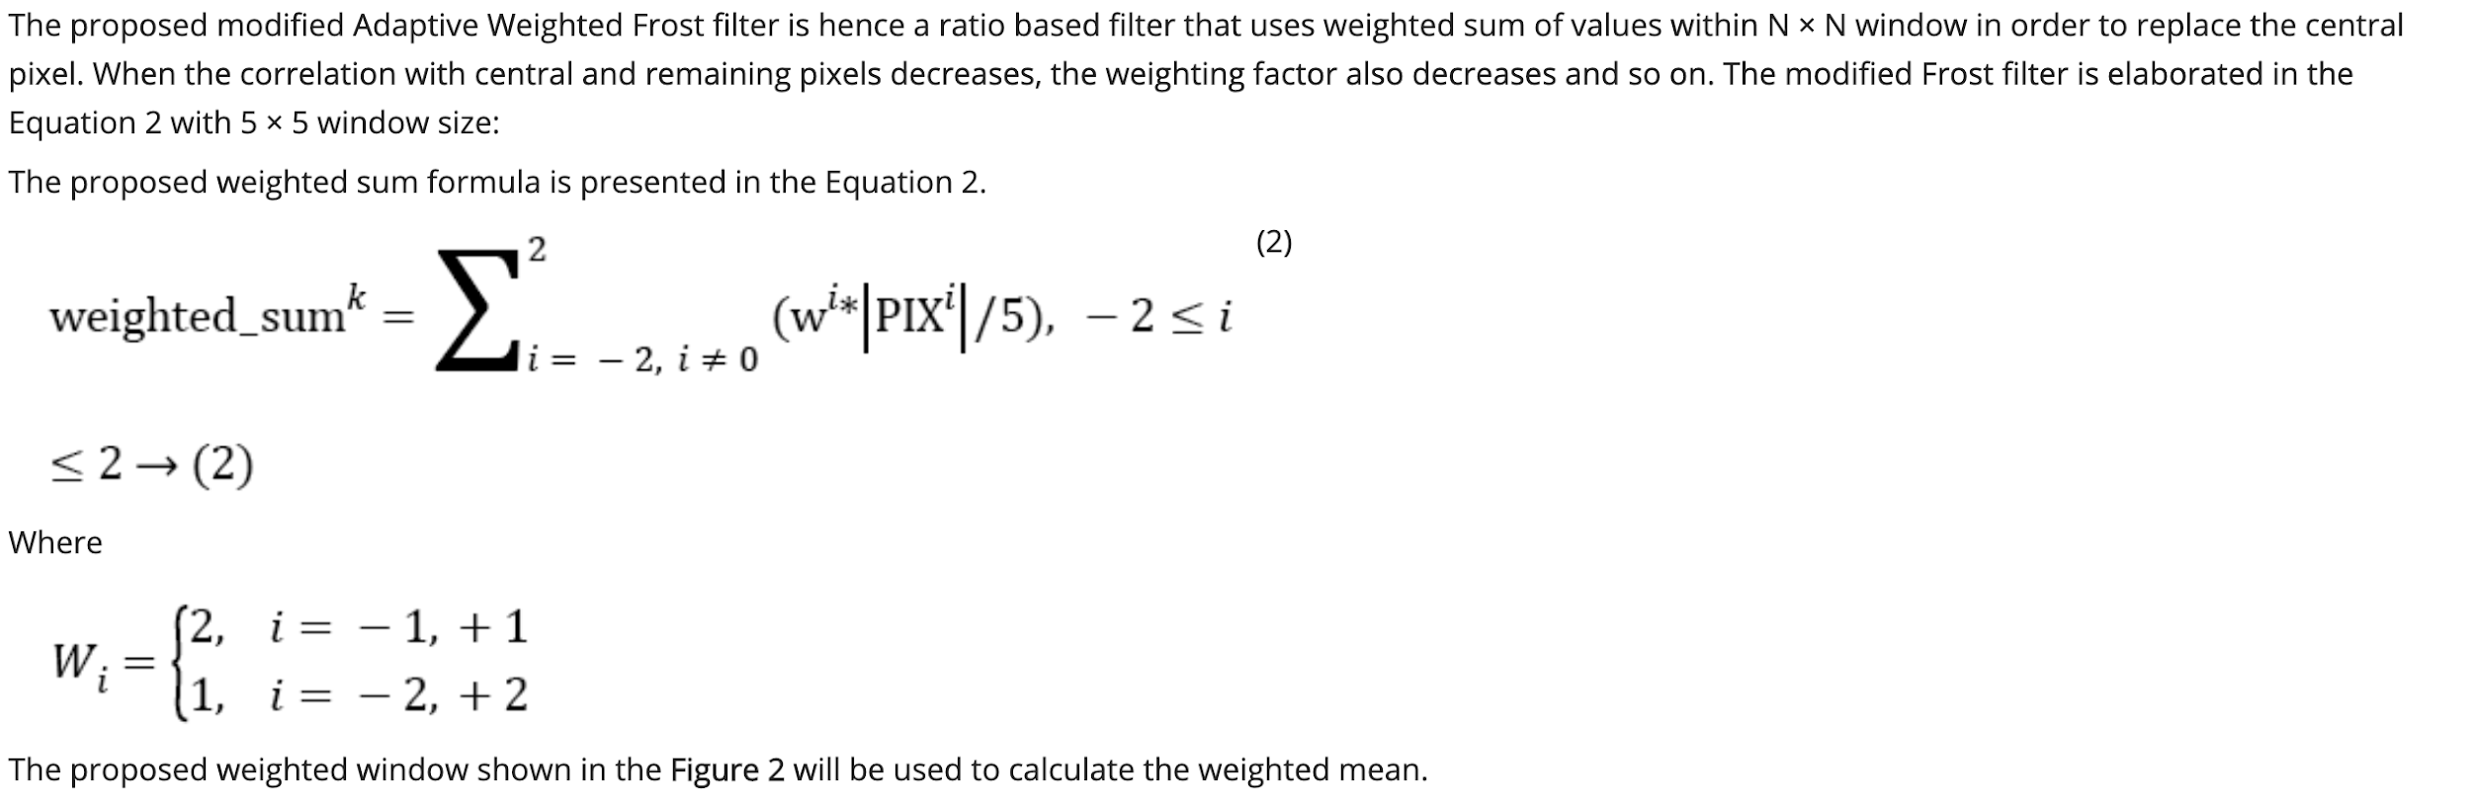

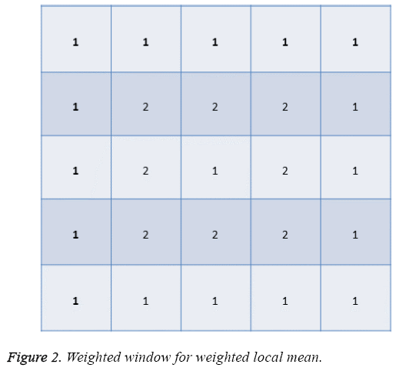

If the **lag distance of two pixels is less, then usually the gray scale values are closer to each other. So accordingly as presented in Figure 2, more weight is assigned to the pixels whose lag distance is 1 and less weight whose lag distance is 2 to create the correlation among adjacent pixels.** Thus the **high correlation of connected pixels is achieved which is very important here since the adjacent pixels contribute well in order to restore the central pixel of degraded image.** Consequently, the resultant pixel value has been replaced by the weighted mean of filter window. That is why the proposed **Adaptive Weighted Frost filter is better to the existing Frost and Wiener filter for quantum noise removal from mammograms.**

**Performance measure**

Peak signal-to-noise ratio (PSNR) is taken as a quantitative measurement in order to evaluate the performance of the proposed Adaptive Weighted Frost filter to remove the quantum from mammograms using the Equation 3 [[19](http://www.biomedres.info/biomedical-research/preprocessing-digital-breast-mammograms-using-adaptive-weighted-frost-filter.html#19)]. The PSNR value ranges from 30 to 50 db is considered acceptable which means that the visual quality of mammogram is improved.

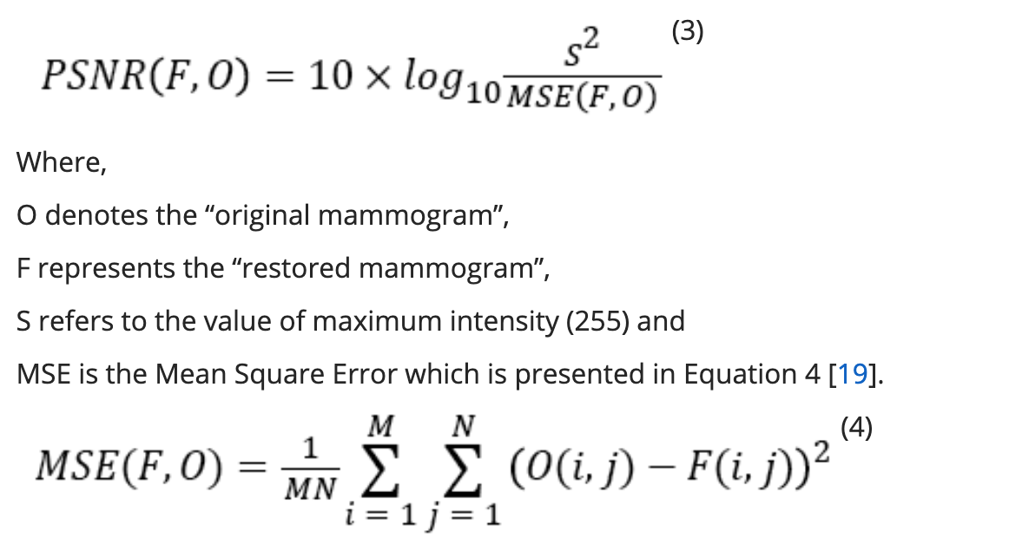

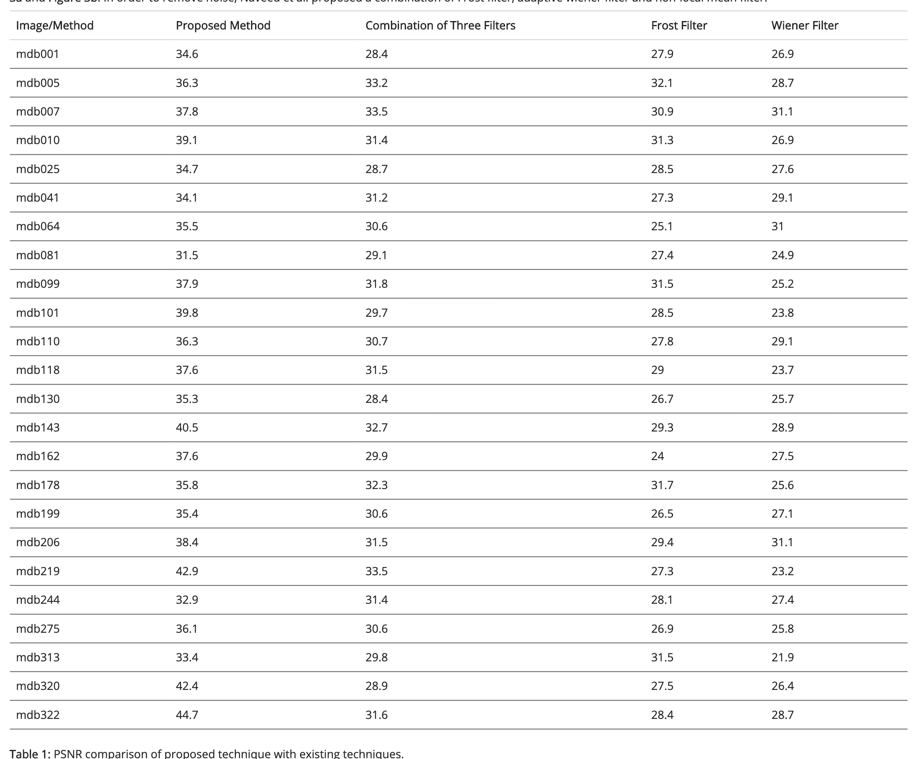

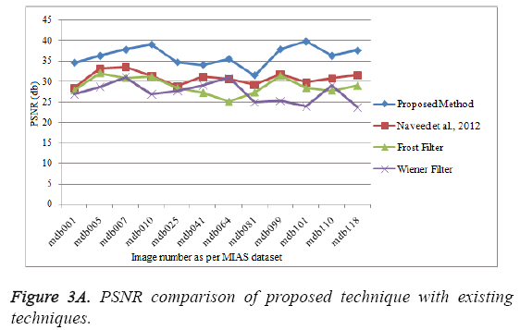

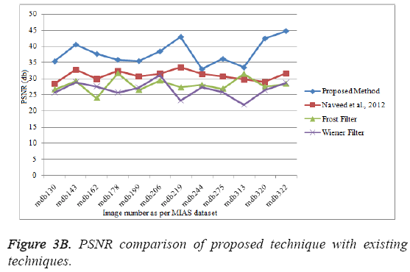

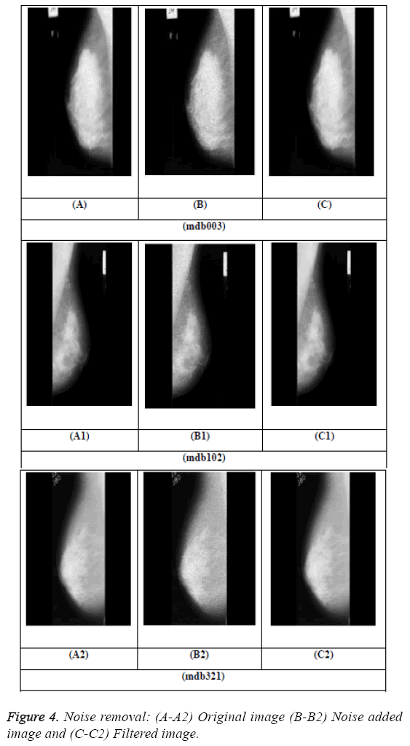**Conclusion**

The presented noise restoration technique by using modified **Frost filter to improve the quality of mammographic images showed promising results.** The results demonstrated that the restored mammograms showed low noise level (**high PSNR**) and better spatial resolution (resemblance to their originals and no artifacts are produced in mammogram images). The preprocessed mammographic images showed better qualitative and quantitative results which are helpful for further processing such as features extraction, micro-calcification detection, breast cancer diagnosis, classification, etc. The proper preprocessing steps also increase the efficiency of CAD (computer aided diagnosis) systems which are used by radiologists for abnormalities detection. The modified Frost filter produced better PSNR values, for example in mdb001, the PSNR values produced by modified Frost filter is 34.6 db, Naveed et al. is **28.4 db, Frost filter 27.9 db and Wiener filter is 26.9 db.** The same trend is shown by all mammographic images which illustrates the supremacy of proposed modified filter for mammograms restoration